**Dr. B R AMBEDKAR NATIONAL INSTITUTE OF TECHNOLOGY**

**JALANDHAR – 144011, PUNJAB (INDIA)**

**JAN-MAY, 2017**



**DEPARTMENT OF COMPUTER SCIENCE AND ENGINEERING**

**DATABASE MANAGEMENT SYSTEM**

**LABORATORY**

**(CSX-224)**

**Submitted To: Submitted By:**

Ms. Kirti Shubham Jain

Assistant Professor 15103046

Dept. of CSE Dept. of CSE

INDEX:

|  |  |  |  |  |
| --- | --- | --- | --- | --- |
| S. No | CONTENT | Page No. | Date | Remarks |
|  | Study of basics of Oracle 12c and installation steps in Windows 8.1 | 3 | 11/1/17 |  |
|  | Study and implementation of DDL and DML Commands in Oracle 12c | 11 | 18/1/17 |  |
|  | Implementation of Logical Operators in SQL commands. | 16 | 25/1/17 |  |
|  | Implementation of SQL Operators, Numeric Functions and Aggregate Functions in SQL commands. | 23 | 1/2/17 |  |
|  | Implementation of STRING FUNCTIONS using SQL commands and queries. | 33 | 8/2/17 |  |
|  | Study and Implementation of CONSTRAINTS like Primary key, foreign key and Unique using SQL commands. | 38 | 15/2/17 |  |
|  | To Apply the FOREIGN KEY CONSTRAINT on SQL queries like  On delete CASCADE, On delete Set NULL, Enable and disable constraint. | 43 | 1/3/17 |  |

Introduction:

A **database management system (DBMS)** is software that controls the storage, organization, and retrieval of data.

A **database application** is a software program that interacts with a database to access and manipulate data.

A **relational database** is a database that conforms to the relational model. The relational model has the following major aspects:

**Oracle Database** is an RDBMS. An RDBMS that implements object-oriented features such as user-defined types, inheritance, and polymorphism is called an **object-relational database management system (ORDBMS)**. Oracle Database has extended the relational model to an object-relational model, making it possible to store complex business models in a relational database. The Oracle Database 12c is a high-performance, enterprise-class database. [Oracle](http://searchoracle.techtarget.com/definition/Oracle) released Oracle Database 12c into general availability July 1, 2013. According to Oracle, this is "the first database designed for the cloud." Oracle Database 12c also introduces 500 new features to the database, most notably pluggable databases and [multitenant architecture](http://whatis.techtarget.com/definition/multi-tenancy). The Oracle Database 12c release 12.0.1.2 also features the [Oracle Database 12c In-Memory](http://searchoracle.techtarget.com/definition/Oracle-Database-In-Memory), an optional add-on that provides in-memory capabilities. The [in-memory](http://whatis.techtarget.com/definition/in-memory-database) option makes Oracle Database 12c the first Oracle database to offer real-time analytics.

One characteristic of an RDBMS is the independence of physical data storage from logical data structures.

In Oracle Database, a database **schema** is a collection of logical data structures, or schema objects. A database user owns a database schema, which has the same name as the **user name**. Schema objects are user-created structures that directly refer to the data in the database. The database supports many types of schema objects, the most important of which are tables and indexes.

A table describes an entity. In general, each **column** is given a name, a **data type**, and a width when you create the table. A table is a set of rows (**tuples**). A column identifies an **attribute** of the **entity** described by the table, whereas a **row** identifies an instance of the entity.

**SQL** is a set-based declarative language that provides an interface to an RDBMS such as Oracle Database. SQL is nonprocedural and describes what should be done. SQL is the ANSI standard language for relational databases. All operations on the data in an Oracle database are performed using SQL statements.

Installation Steps:

1. Open a web browser of your choice and navigate to <http://otn.oracle.com/windows>.
2. 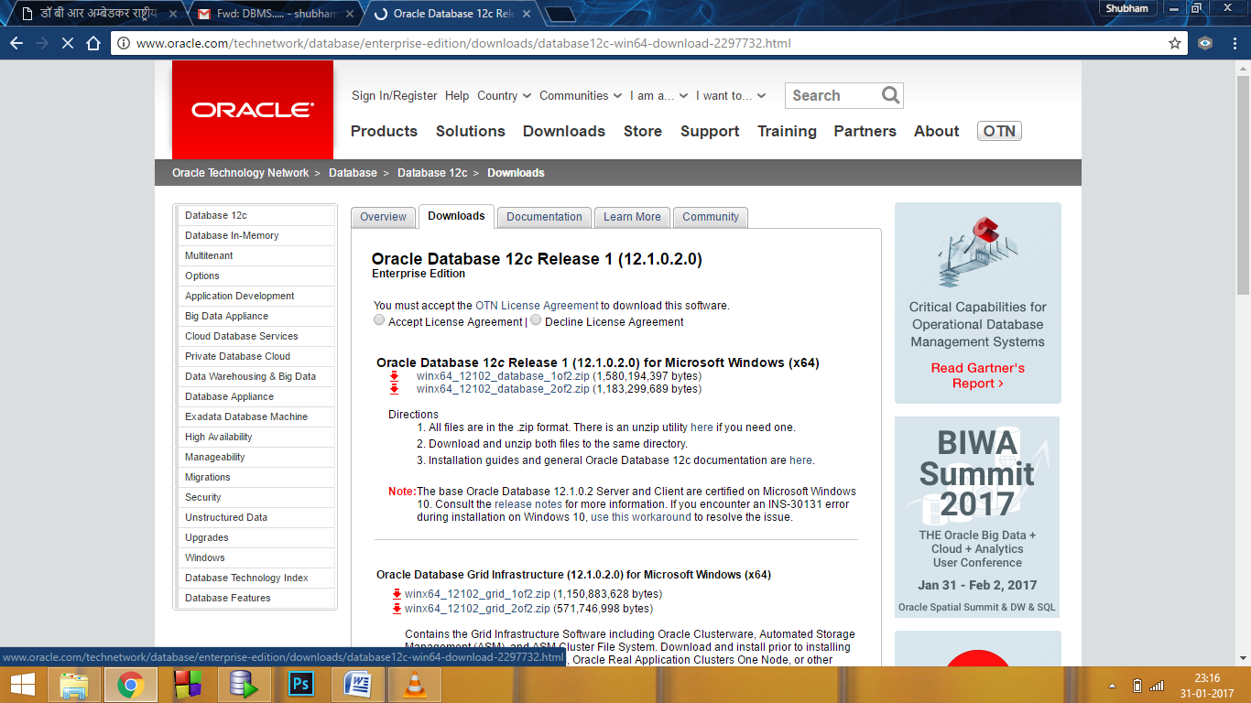Go to the download Section and Click on the latest version of **Oracle Database 12c (x64)**.
3. In this OBE, we install Oracle Database 12c. Accept the license agreement and click the files under **Oracle Database 12c Release ... for Microsoft Windows (x64)** to download.
4. Expand the**database** folder that is extracted after downloading the database system. Double-click **setup**.
5. The **Configure Security Updates** window appears. Enter your email address and My Oracle Support password to receive security issue notifications via email. If you do not wish to receive notifications via email, deselect "**I wish to receive security updates via My Oracle Support**". Click **Next** to continue.

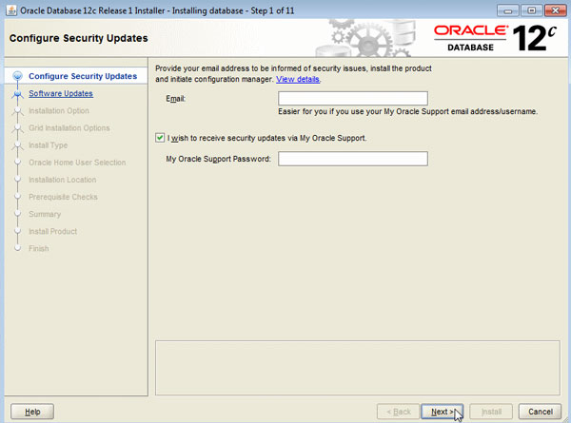Click "**Yes**" in the confirmation window to confirm your preference.

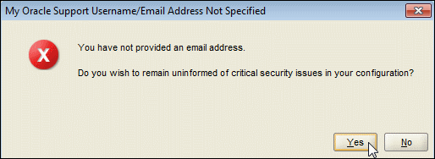

1. The **Select Installation Option** window appears with the following options:
2. Select **"Create and configure a database"** to install the database, create database instance and configure the database.

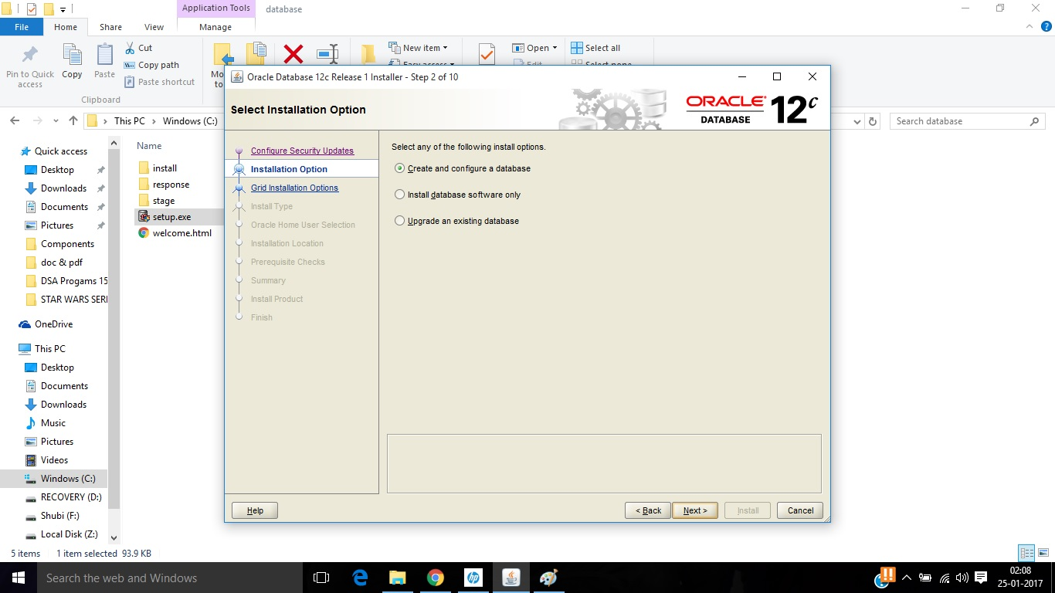

1. The **System Class** window appears. Select Desktop Class or Server Class depen

ding on the type of system you are using. In this OBE, we will perform the installation on a desktop/laptop. Select **Desktop class** and click **Next**.

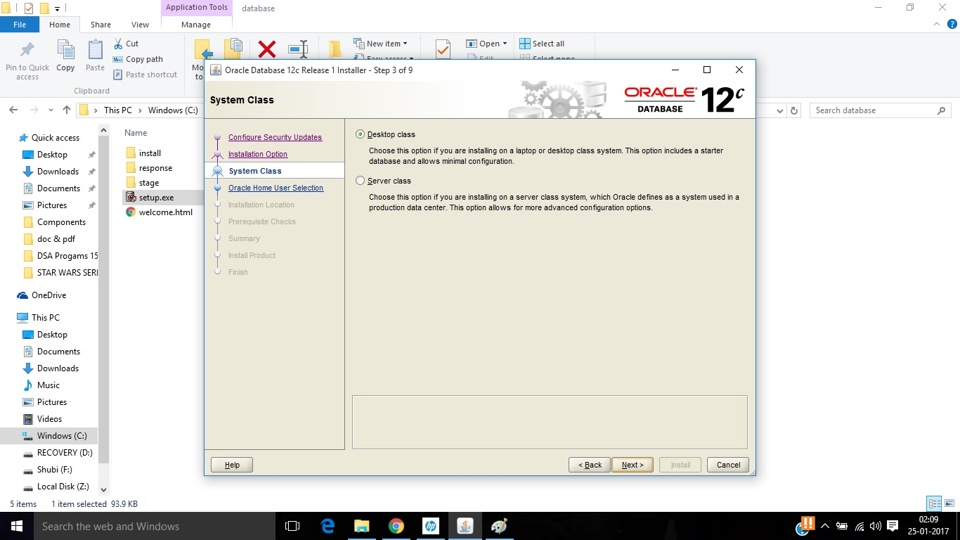

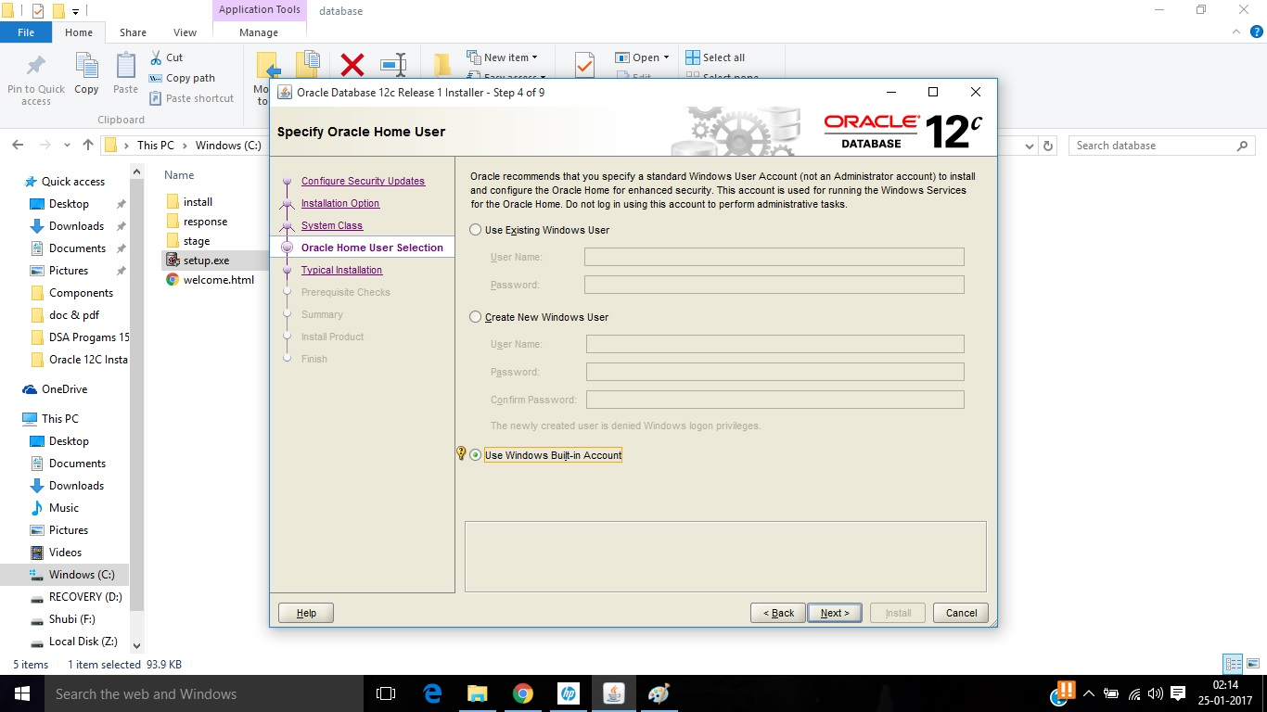

1. The **Oracle Home User Selection**window appears. Select "**Use Windows Built-in Account**", the system uses the Windows Built-in account as the Oracle Home User.

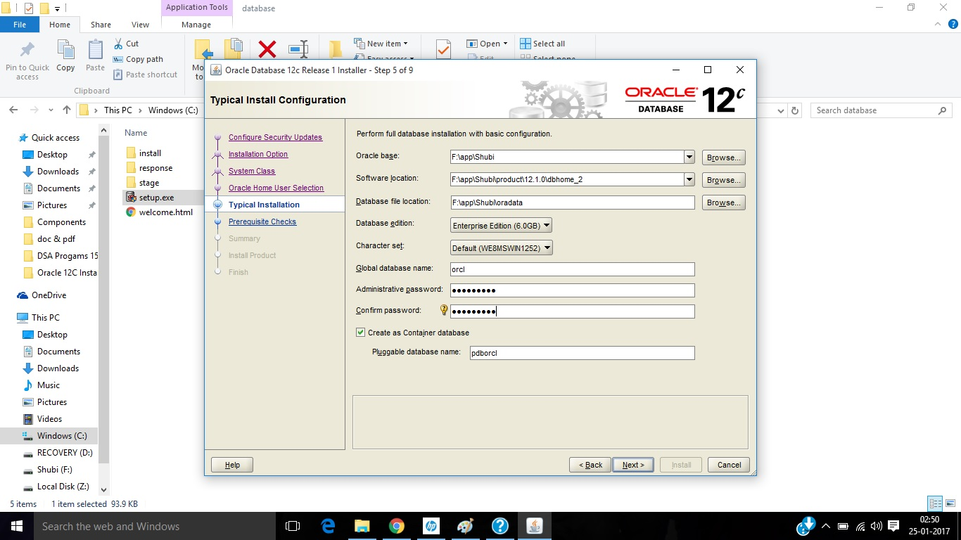

1. 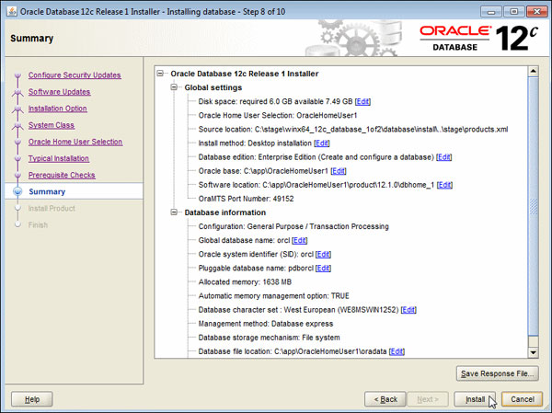The prerequisite checks are performed and a **Summary**window appears. Review the settings and click **Install**.
2. The progress window appears.

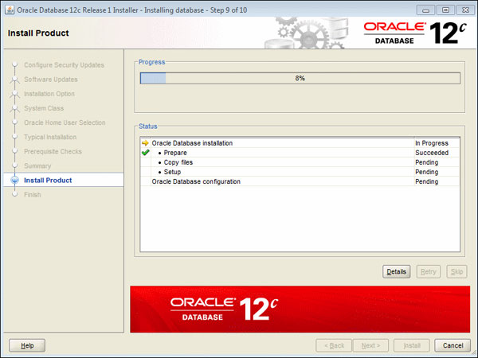

1. After the Database Configuration Assistant creates the database, you can navigate to <https://localhost:5500/em> as a SYS user to manage the database using Enterprise Manager Database Express. You can click "Password Management..." to unlock accounts. Click **OK** to continue.
2. 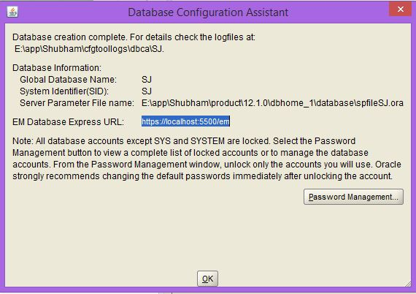**Oracle 12c** is installed in this way.

|  |
| --- |
|  |
|  |
|  |

**LAB 1**

**Aim:** Create a table student(including a minimum of 5 columns and 5 attributes in it) and apply various DDL and DML commands on that table to perform basic operations.

**Software used:** Oracle 12c SE

**Theory:** **DDL AND DML COMMANDS**

1. **DDL :** Data Definition Language(a.k.a Data Description Language) is a computer language used to create and modify the structure of database objects in a database, these includes views, schemas and tables. Some of the commands are:-
   1. **CREATE:**  The create table command defines each column of the table uniquely. Each table column definition is separated from the other by a comma.

**SYNTAX:**

Create table <tablename> (attributes and their datatypes)

**1.2 RENAME:** Rename command is used to change name of a table

**SYNTAX:**

RENAME <old table name> to <new table name>

* 1. **ALTER :** By use of alter table command we can modify our existing table
     1. **:** We can add new columns by using alter table command

**SYNTAX:**

Alter table <tablename> add (<new column name> <datatype>(<size>),…)

* 1. **.2 :** We can drop a column using **alter** command

**SYNTAX**:

Alter table <tablename> drop column <column name>

**1.3.3 :** We can modify a column i.e. change the datatype of the attribute using **alter** command

**SYNTAX:**

Alter table <tablename> modify (<column name> <new data type> (<new size>))

**2. DML commands:** Data Manipulation Language is used for managing data within schema objects. Some commands are:-

**2.1 INSERT :** Using insert command we can add values into tables

**SYNTAX:**

insert into <table_name> values (<value1>,<value2>,…)

* Insertion into selected columns

insert into <table_name> (<column1>,<column2>,…) values (<value1>,<value2>,…)

**2.2 DELETE:** Delete command can remove selected rows from the table or all the rows

**SYNTAX:**

* All the rows

Delete from <tablename>

* Selected rows

Delete from <table_name> where <condition>

**2.3 UPDATE:** Update command is used to change the data values in the table

**SYNTAX:**

Update <table_name> set <attribute_name>=<value> where <condition>

**2.4 SELECT:** Once data has been inserted into the table the next most logical operation is to view what has been inserted SELECT verb is used to view this.

**SYNTAX:**

* All the rows and columns

Select * from <tablename>

**2.5 ELIMINATING DUPLICATES:**

Select distinct * from <table_name>

* Only some columns and eliminating duplicates

Select distinct <column1>,<column2>,… from <table_name>

**Queries:**

1. create table student(Name Char(20),Roll_No int,Age int,Gender char(1),City Char(20))
2. insert into student values('Shubham Jain',46,19,'M','Jammu')
3. insert into student values('Shubham Singh',38,18,'M','Patiala')
4. insert into student values('Ankita Garg',06,20,'F','Jalandhar')
5. insert into student values('Arzoo',15,18,'F','Jalandhar')
6. insert into student values('Akashdeep',25,18,'M','Jalandhar')
7. insert into student values('Shelly',12,20,'F','Bhatinda')

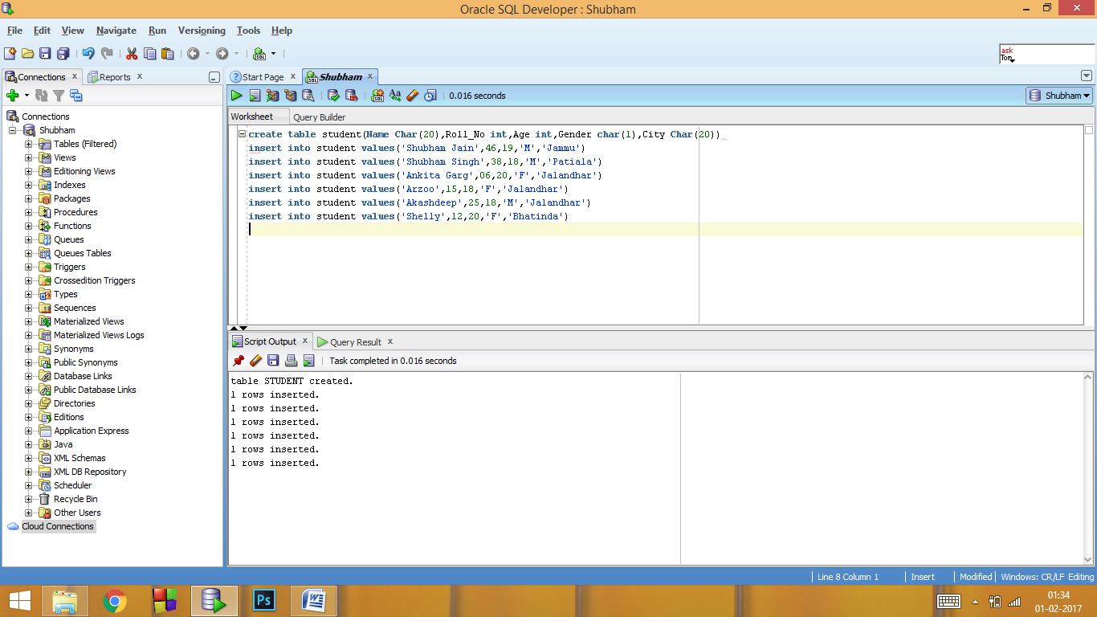

1. select * from student

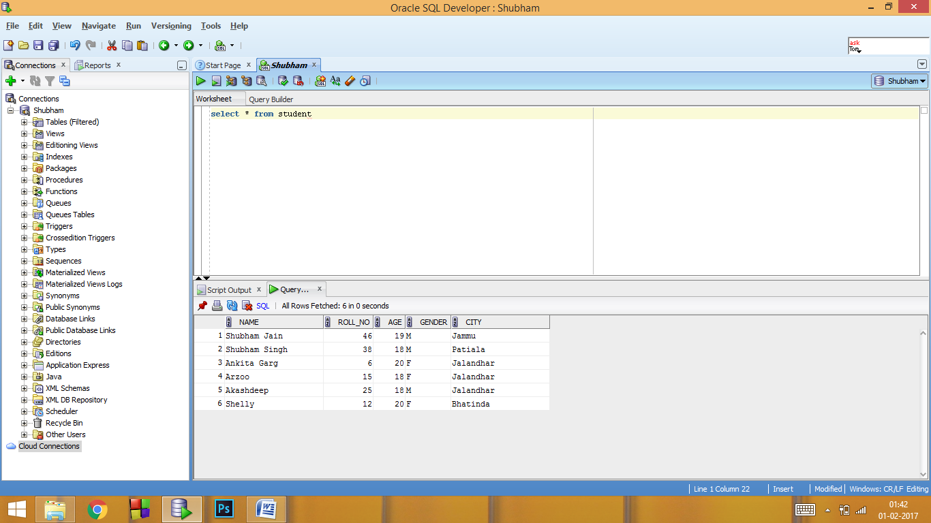

1. alter table student add(college char(6),fees int)

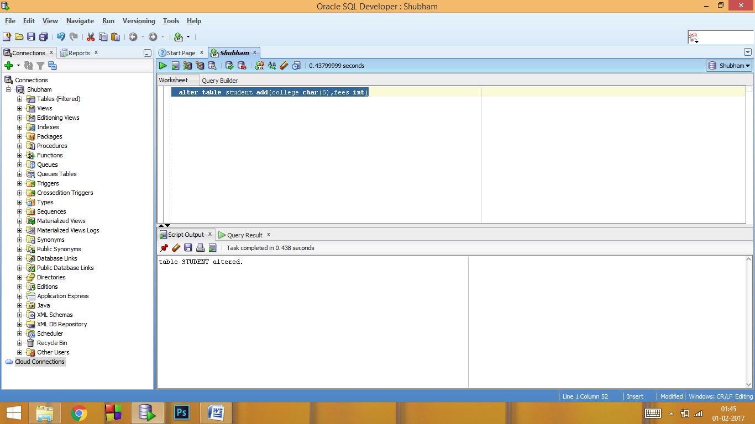

1. update student set college='NITJ',fees=44000

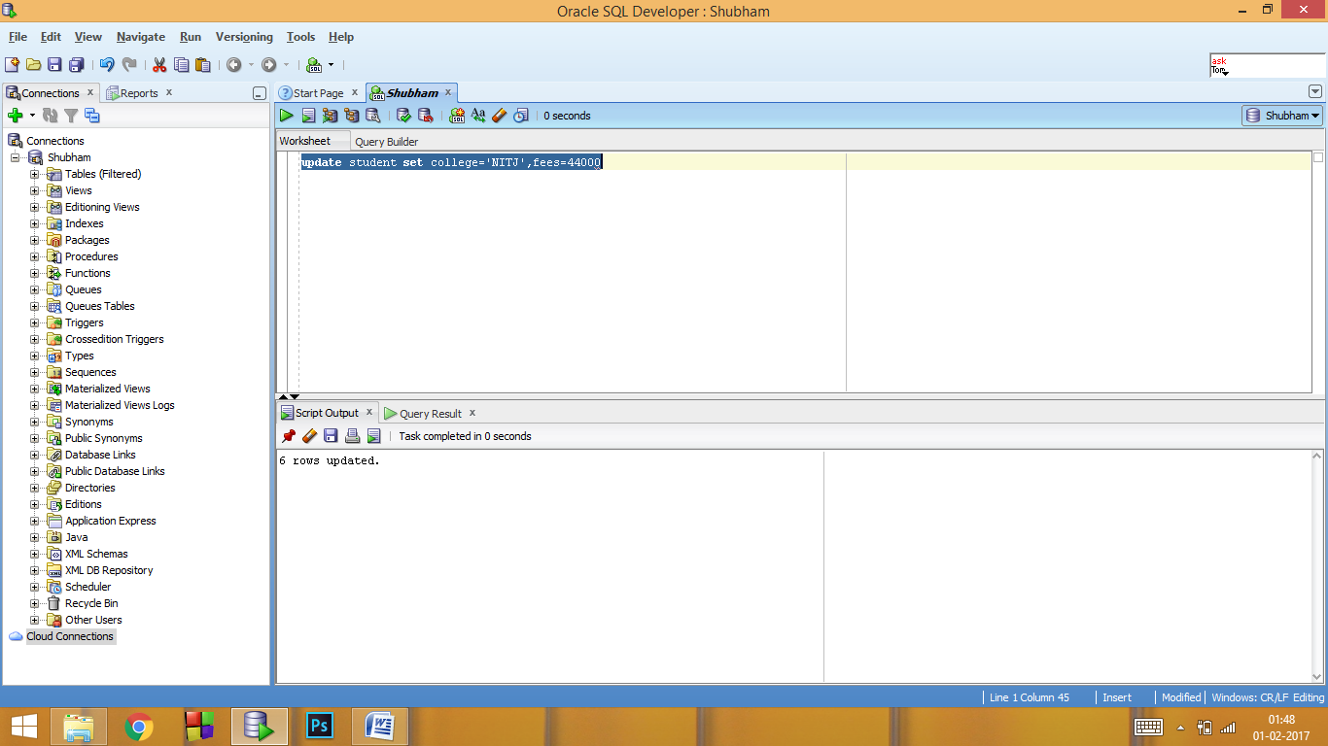

1. select * from student

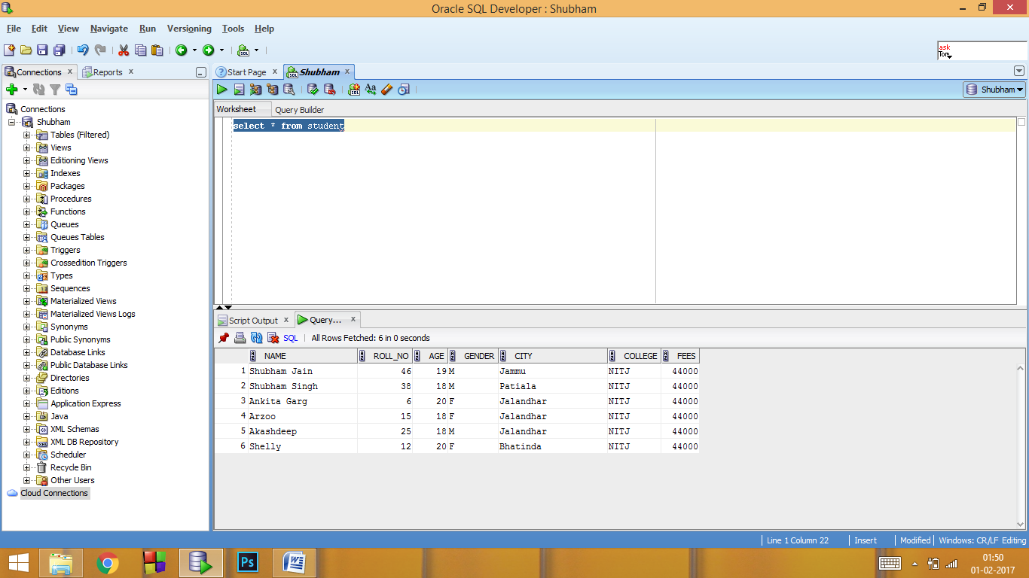

**Lab 2**

**Aim:** To Perform the Given statements using SQL commands and queries.

1. Retrieve DATA from student table when city must be Jalandhar and Roll No. Must be 15.
2. Retrieve DATA from student table when city must be Jalandhar or Roll No. Must be 15.
3. Retrieve DATA from student table where Roll No. is not greater than 25.
4. Retrieve student name from student table where city is Jalandhar and Roll No. is 25 and age must be greater than 10.
5. Retrieve student name from student table where city is Jalandhar or Roll No. is 25 and age must be other than 10.
6. Retrieve age from student table where city is other than Jalandhar and Roll No. must be 15.
7. Retrieve DATA from student table where city is other than Jalandhar and age must be other than 15 and Roll No. must be other than 18.
8. Retrieve DATA from student table where city is other than Jalandhar and age must be other than 15 and Roll No. must not be equal to other than 18.
9. Retrieve DATA from student table where city is not other than Jalandhar or age must be other than 15 and Roll No. must be greater than 18.
10. Retrieve DATA from student table where city is not other than Jalandhar or Age must not be other than 15 and roll no. must be greater than 18 and other than 21.

**Software Used**: Oracle 12c SE

**Theory: LOGICAL OPERATORS:**

There are three logical operators namely, AND, OR and NOT. These operators compare two conditions at a time to determine whether a row can be selected for the output.

1. **OR:** For the row to be selected at least one of the conditions must be true.
2. **AND:** For a row to be selected all the specified conditions must be true.
3. **NOT:** For a row to be selected the specified condition must be false.

**Queries:** Complete table is as under

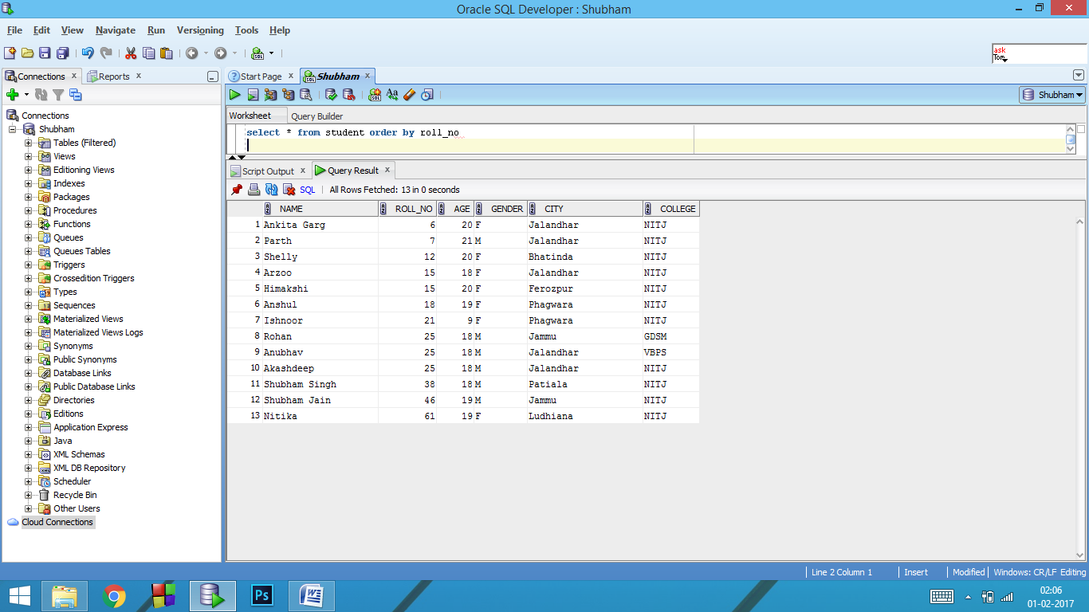

* select * from student order by roll_no

Answers:-

1. select * from student where city='Jalandhar' and roll_no= 15

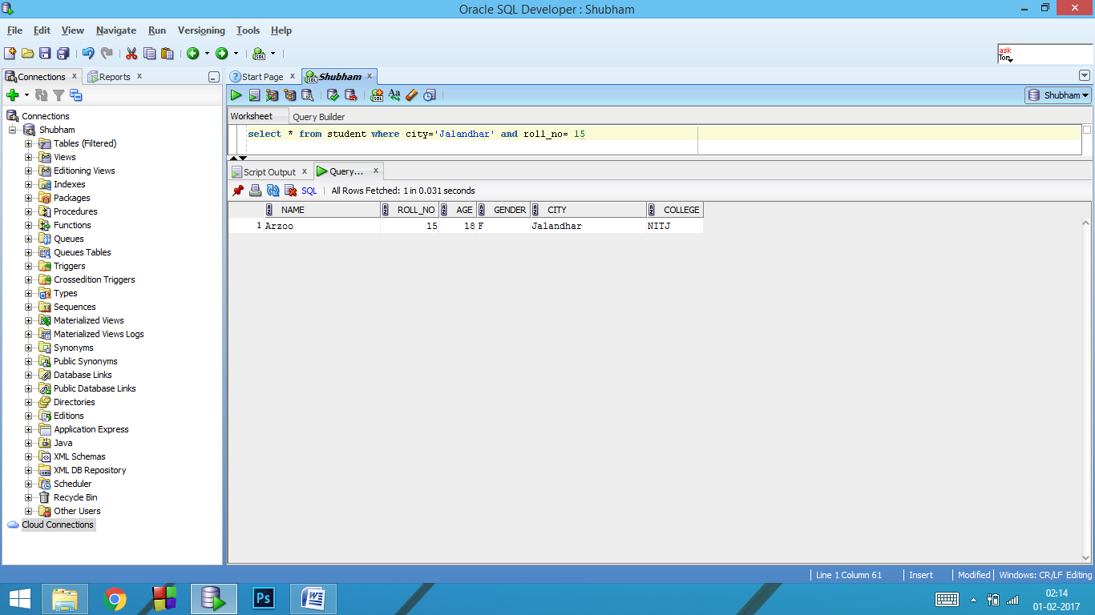

1. select * from student where city='Jalandhar' or roll_no= 15

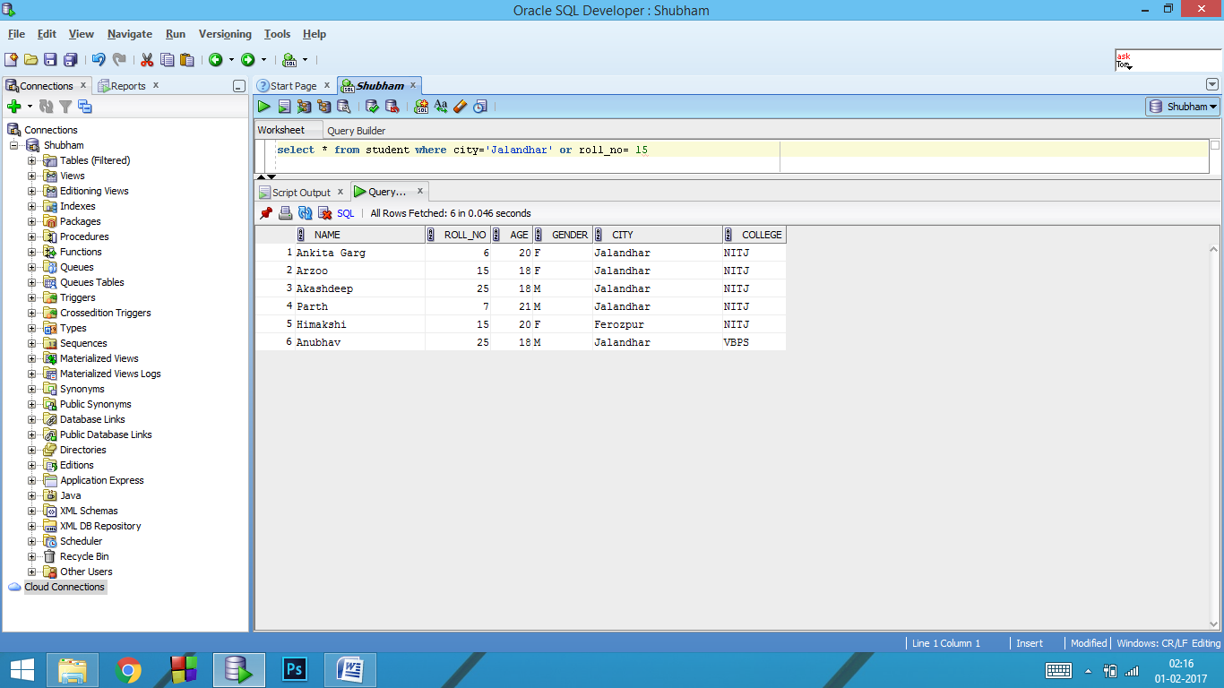

1. select * from student where not(roll_no> 25)

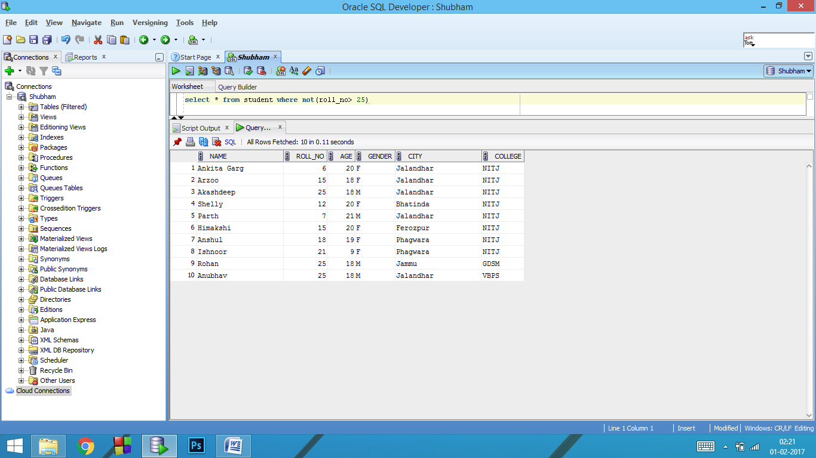

1. select name from student where city='Jalandhar' and roll_no= 25 and age>10

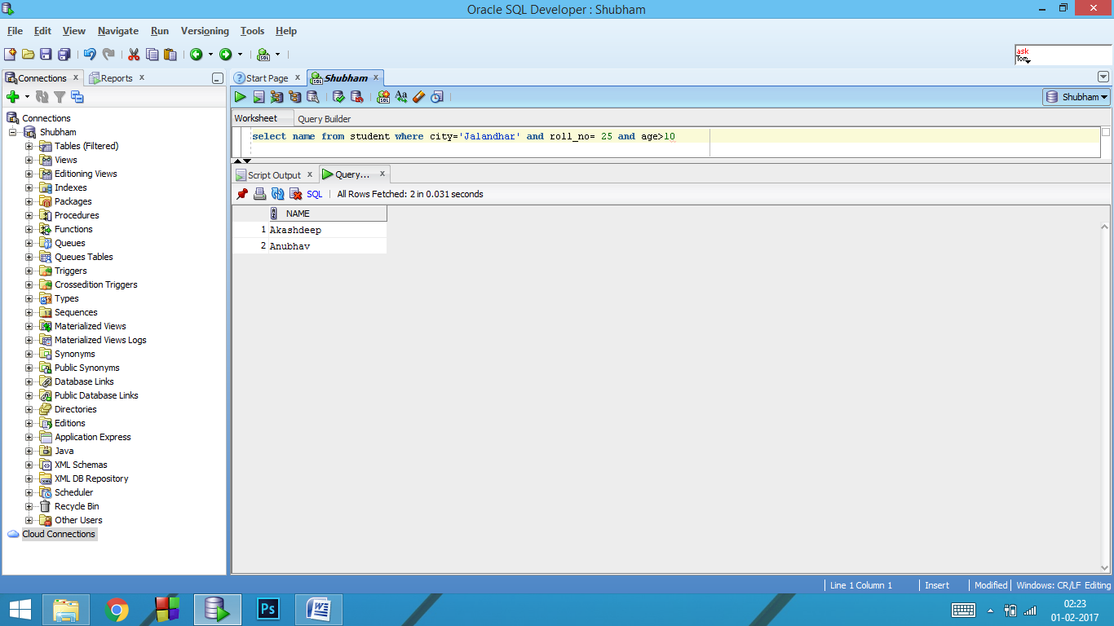

1. select name from student where city='Jalandhar' or roll_no= 25 and age<>10

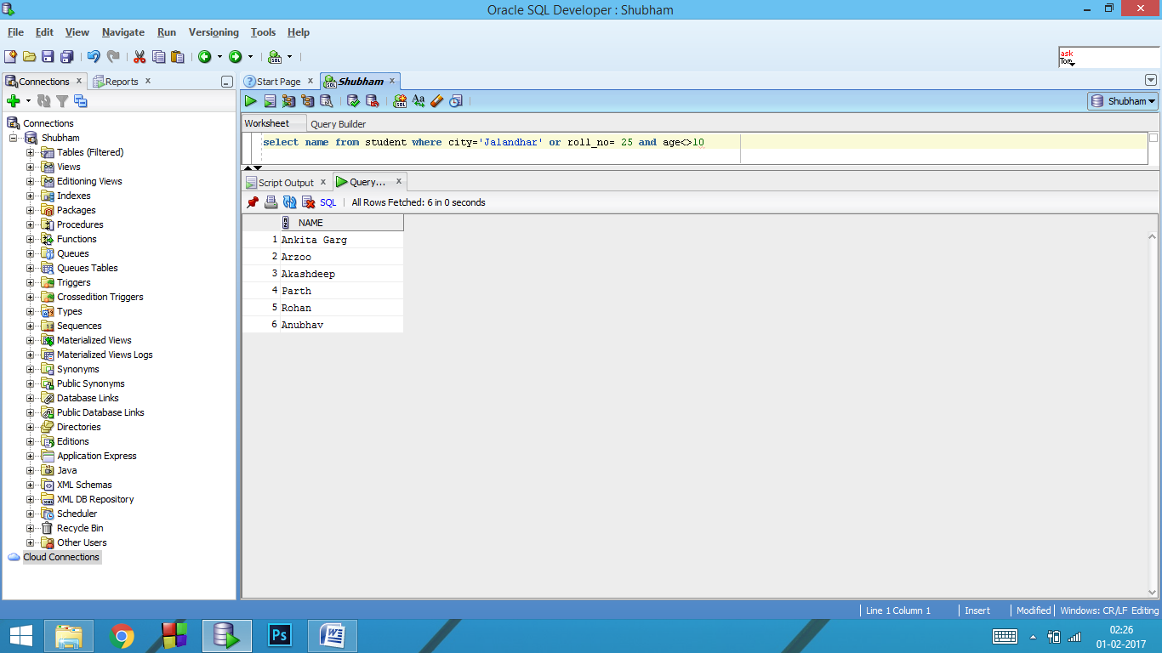

1. select * from student where city<>'Jalandhar' and roll_no=15

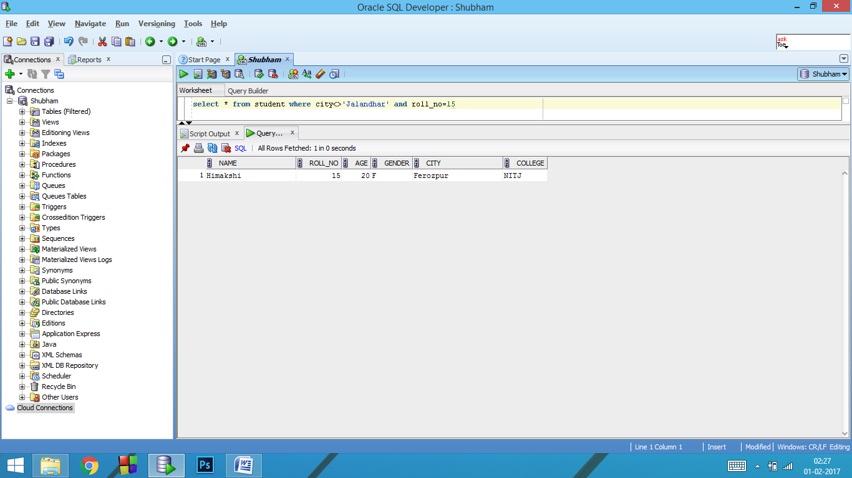

1. select * from student where not(city='Jalandhar') and roll_no<> 18 and not(age=15)

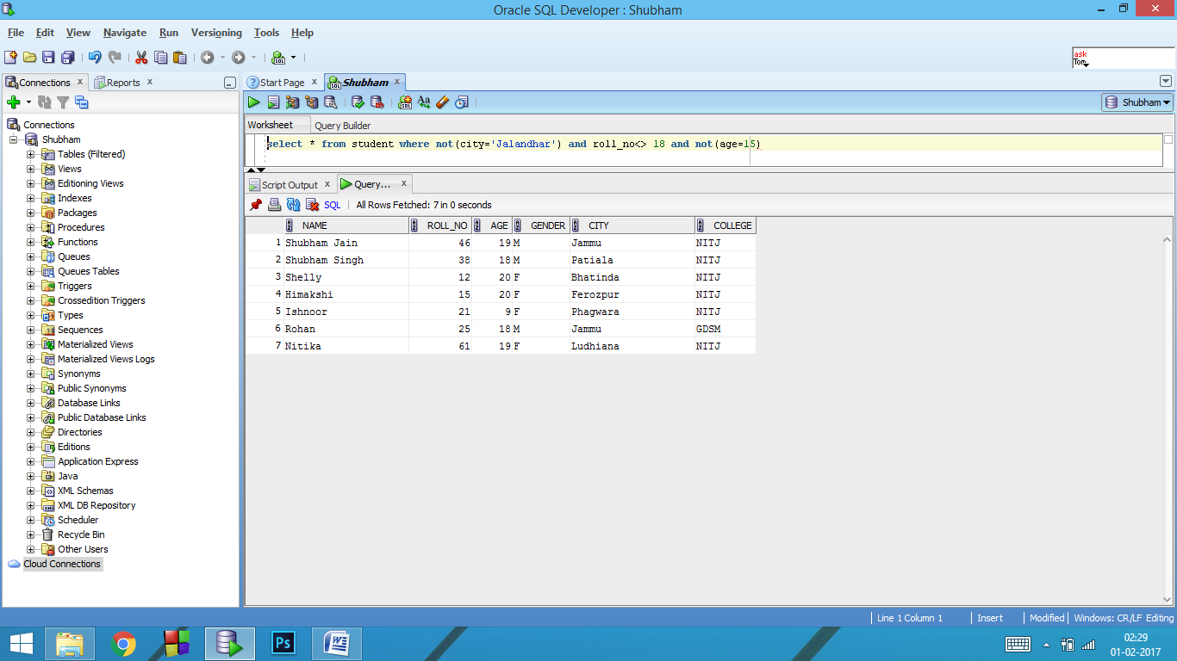

1. select * from student where not(city='Jalandhar') and roll_no= 18 and not(age=15)

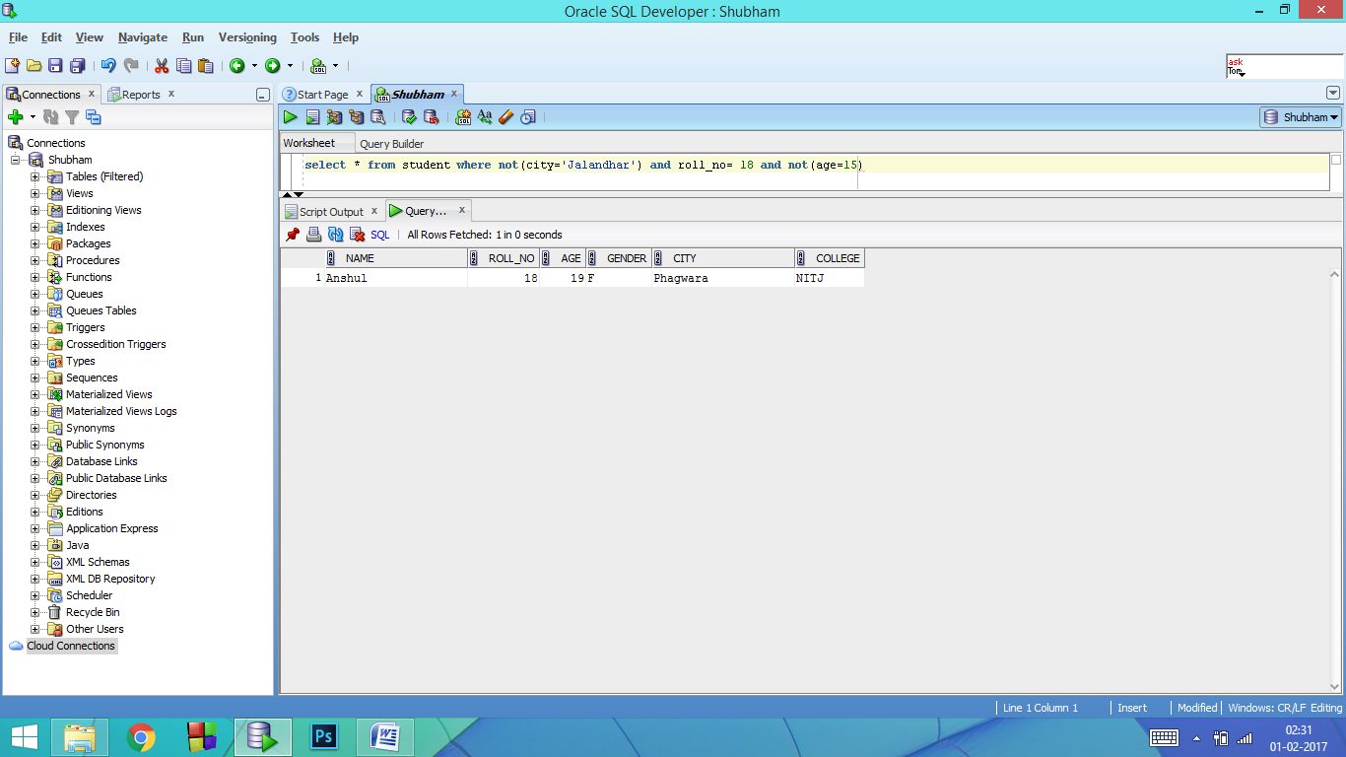

1. select * from student where (city='Jalandhar' or ( age<>15)) and roll_no>18

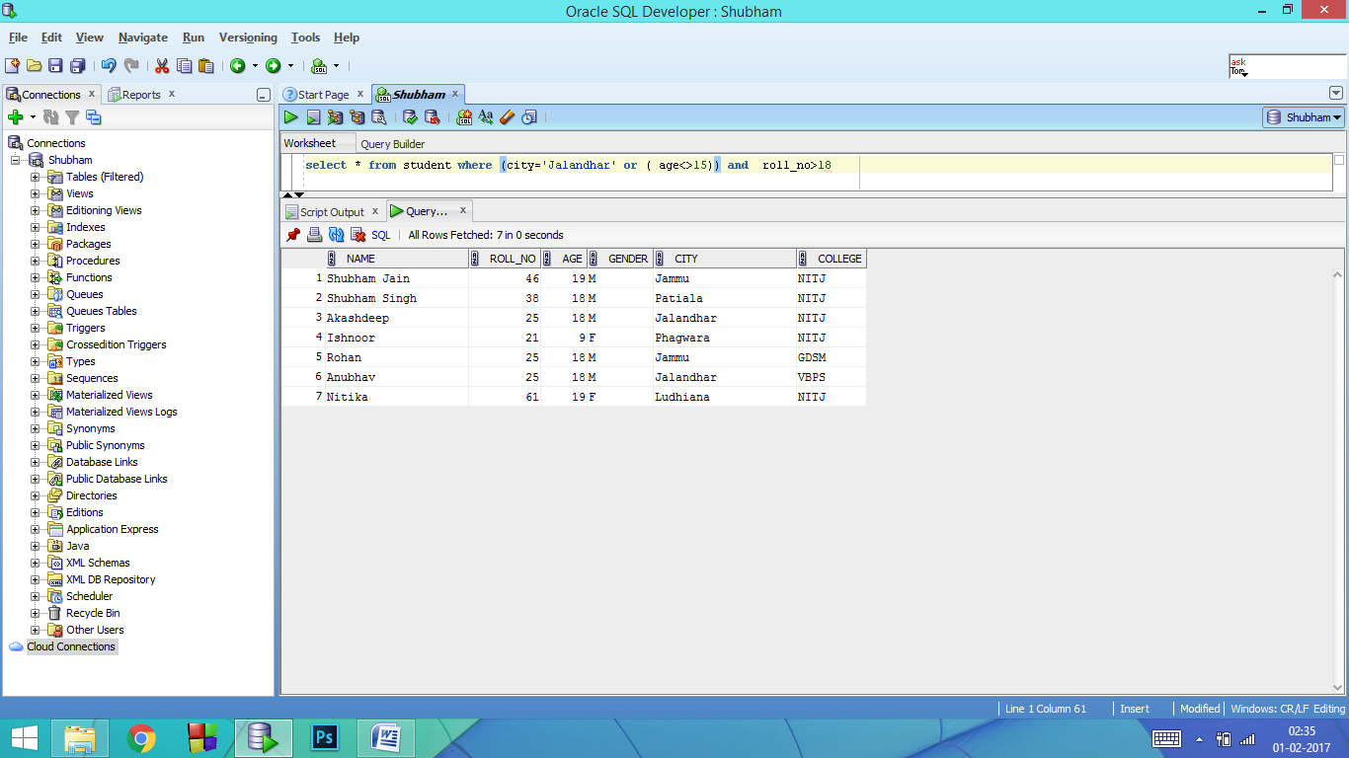

1. select * from student where (city='Jalandhar' or age=15) and roll_no>18 and roll_no<>21

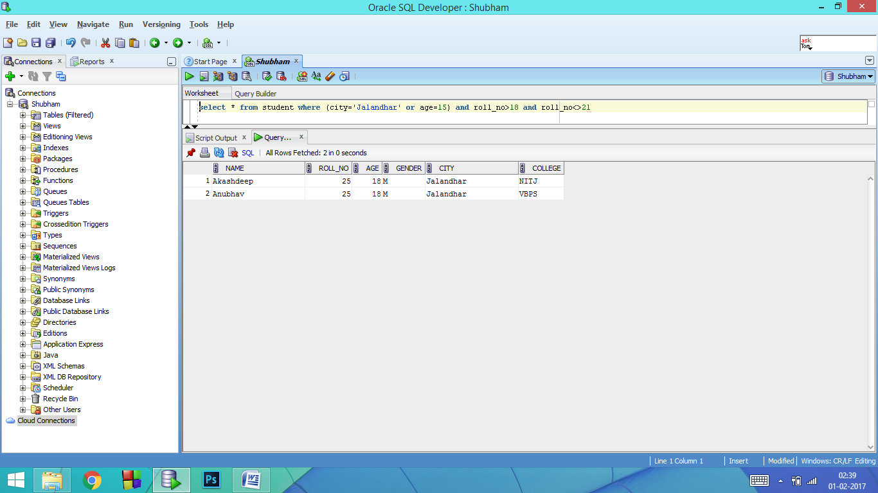

**Lab 3**

**Aim:** To Perform the Given statements using SQL commands and queries.

1. Retrieve Roll No, Name, City, Age from student where Age is between 20 and 25.
2. Retrieve Roll No, Name, City, Age from student where Age is not between 20 and 25.
3. Retrieve Name from student where Name begins with letters ‘Sh’.
4. Retrieve DATA from student where second character of the names are either ‘a’ or ‘k’.
5. Retrieve Roll No, Name, City from student where city is either Jalandhar or Jammu or Bhatinda.
6. Retrieve Roll No, Name, City from student where city is neither Jalandhar nor Jammu nor Bhatinda.
7. Try some of the AGGREGATE FUNCTIONS.
8. Try some of the NUMERIC FUNCTIONS.

**Software Used**: Oracle 12c SE

**Theory: SQL OPERATORS:**

1. **Between Operator:** This operator selects values within a range. The values can be numbers, text or dates.

**SYNTAX:** SELECT column_name(s) FROM table_name where column_name BETWEEN value1 AND value2.

1. **In Operator:** This operator allows us to specify multiple values in a WHERE clause.

**SYNTAX:** SELECT column_name(s) FROM table_name WHERE column_name IN(value1, value2,…).

1. **Like Operator:** The LIKE operator is used to search for a specified pattern in a column.

**SYNTAX:** SELECT column_name(s) FROM table_name WHERE column_name LIKE pattern

**AGGREGATE FUNCTIONS:** SQL aggregate functions return a single value, calculated from values in a column.

Useful aggregate functions:

1. **AVG() –** Returns the average value .
2. **COUNT() –** Returns the number of rows
3. **MAX() –** Returns the largest value
4. **MIN() –** Returns the smallest value
5. **SUM() –** Returns the sum.

**NUMERIC FUNCTIONS:** SQL numeric functions are used primarily for numeric manipulation and/or mathematical calculations.

Some of them are:

1. **ABS() –** Returns the absolute value of the numeric expression.
2. **POWER() –** Returns the value of one expression raised to the power of another expression.
3. **ROUND() –** Returns numeric expression rounded to an integer. Can be used to round an expression to a number of decimal points
4. **SQRT() –** Returns the non-negative square root of an numeric expression.



**Queries:** Complete table is as under

* select * from student order by roll_no

Answers:-

1. select Roll_no, Name, City, age from student where age between 20 and 25

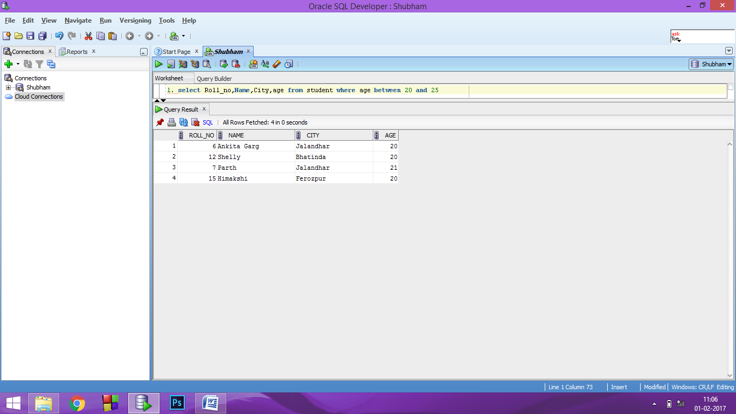

1. select Roll_no, Name, City, age from student where not (age between 20 and 25)

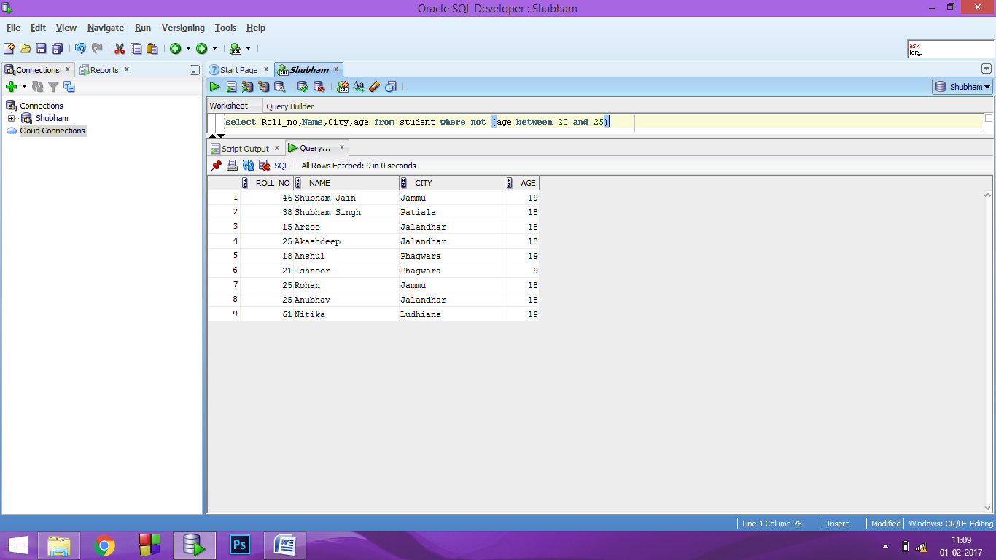

1. select name from student where name like 'Sh%'

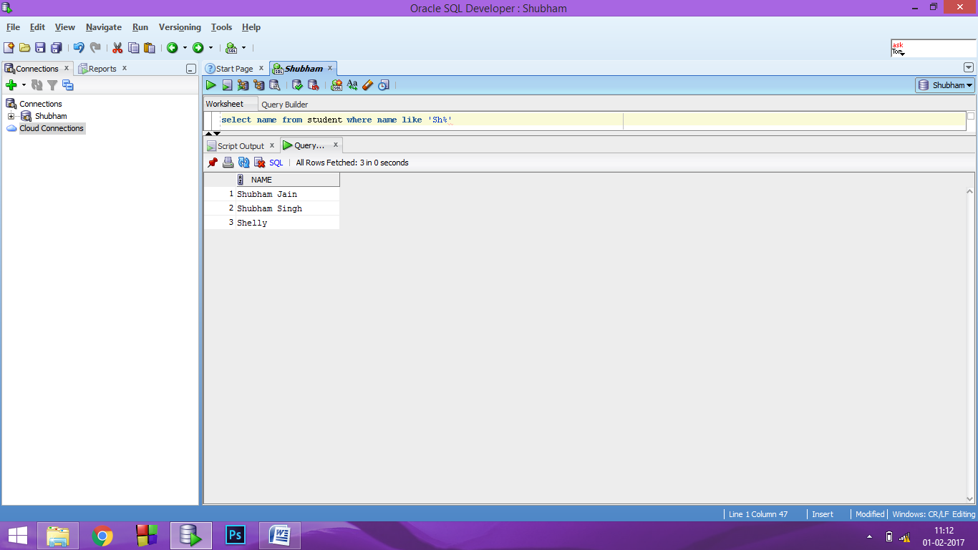

1. select * from student where name like '_a%' or name like '_k%'

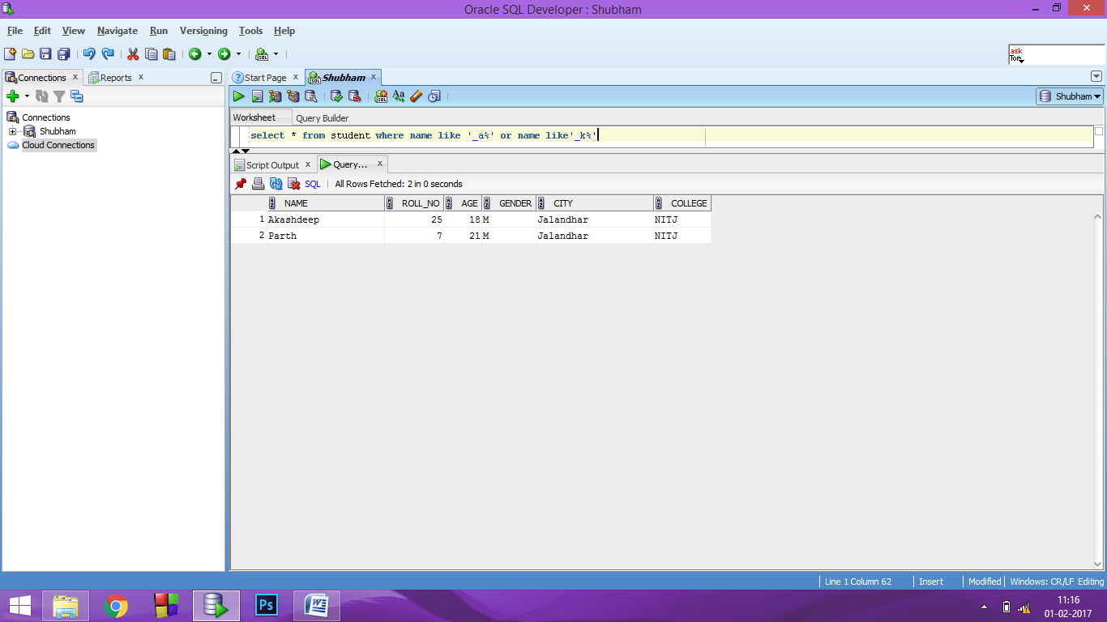

1. select Roll_no, Name, City from student where city in('Jalandhar','Jammu','Bhatinda')

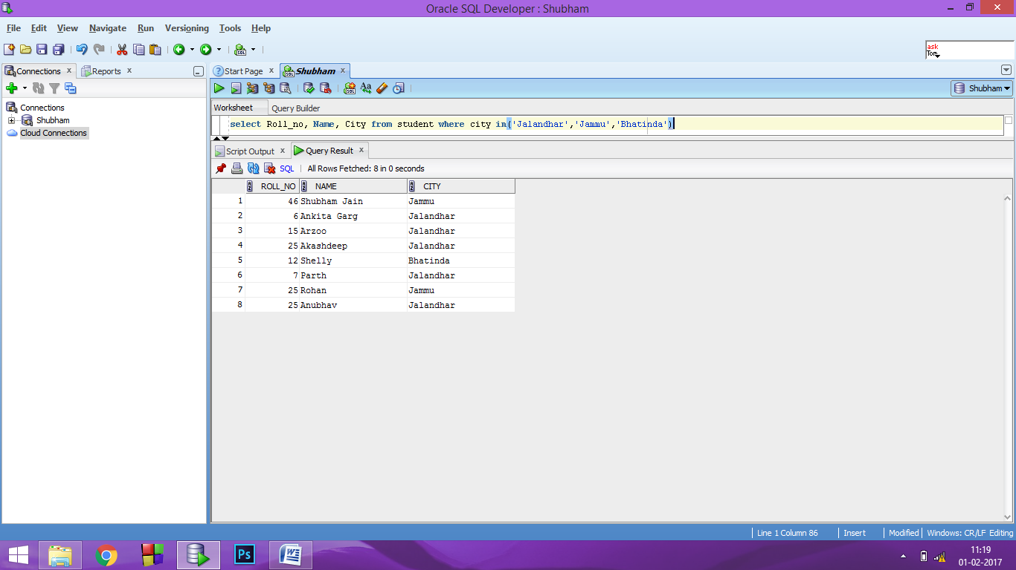

1. select Roll_no, Name, City from student where not (city in('Jalandhar' ,'Jammu', 'Bhatinda'))

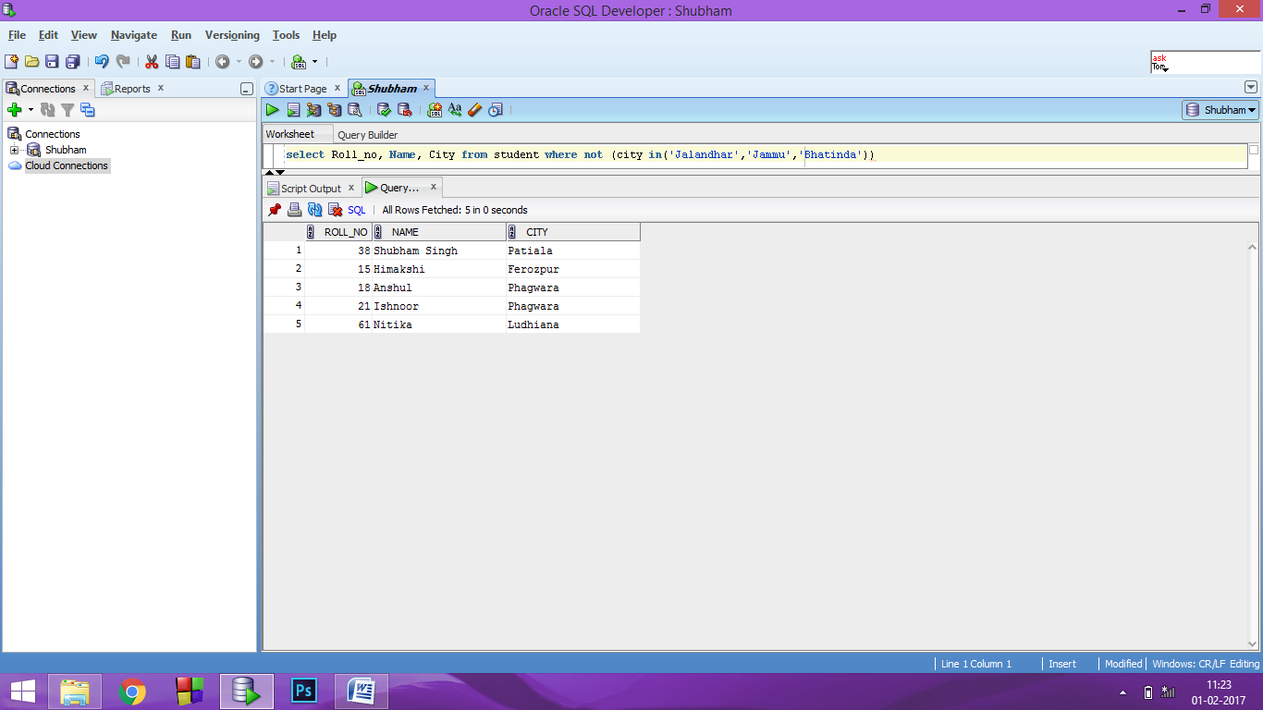

1. AGGREGATE FUNCTIONS:

7.1) AVG( ) – select avg(cg) "AVERAGE CG" from student

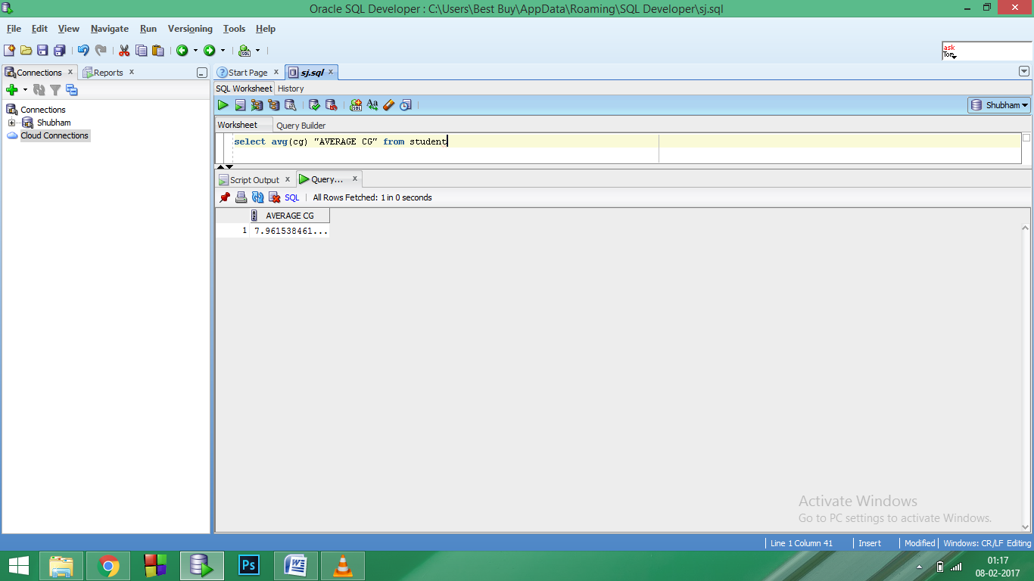

7.2) COUNT( ) - select count(Name) "MALES" from student where gender='M'

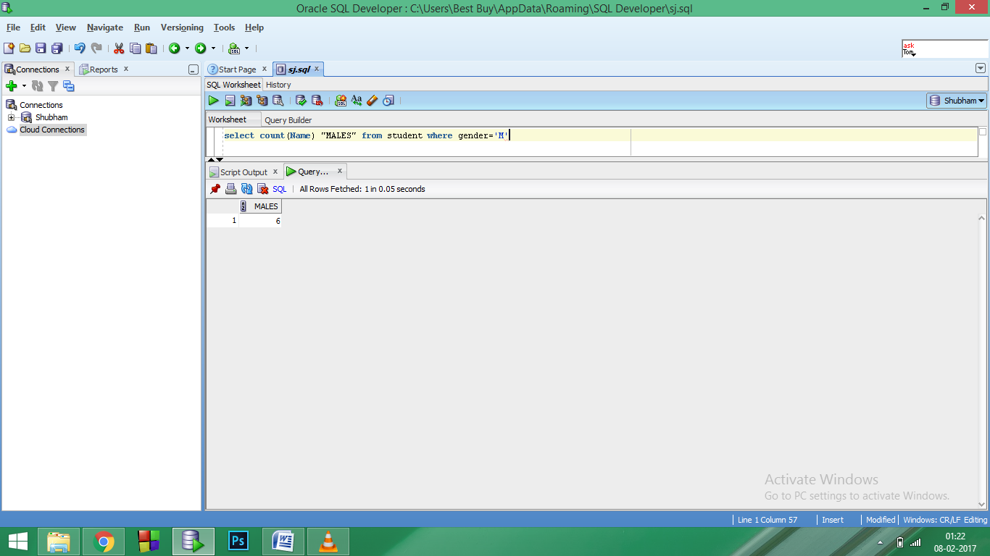

7.3) MAX( ) - select max(cg) as "MAXIMUM CG" from student

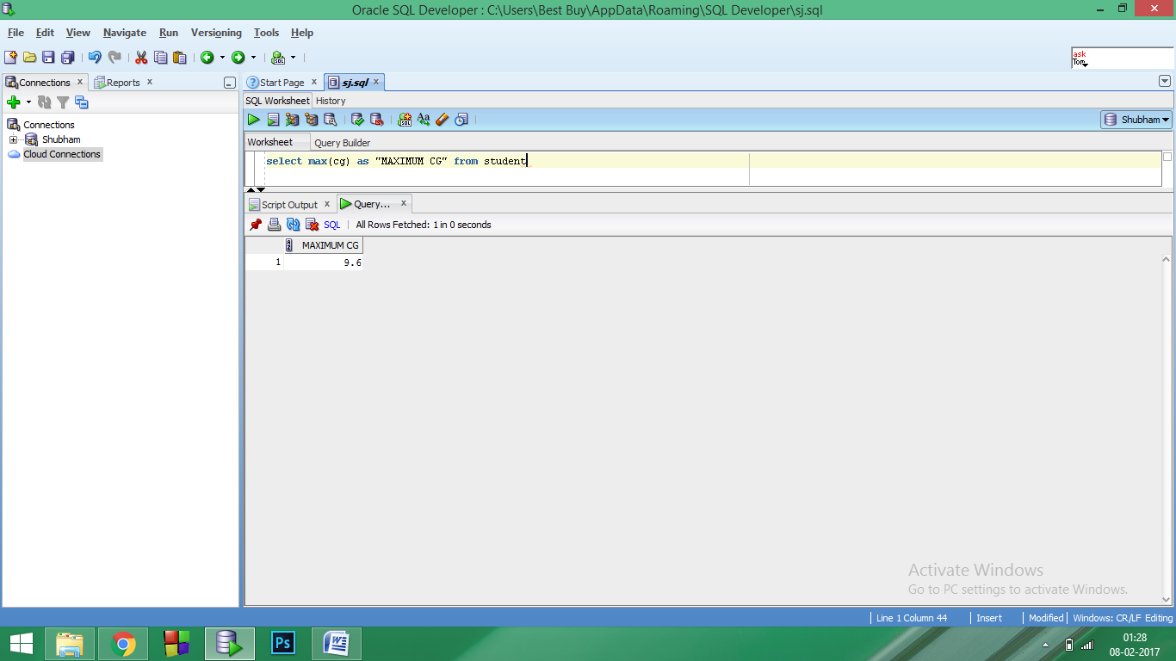

7.4) MIN( ) - select min(age) as "MINIMUM AGE" from student

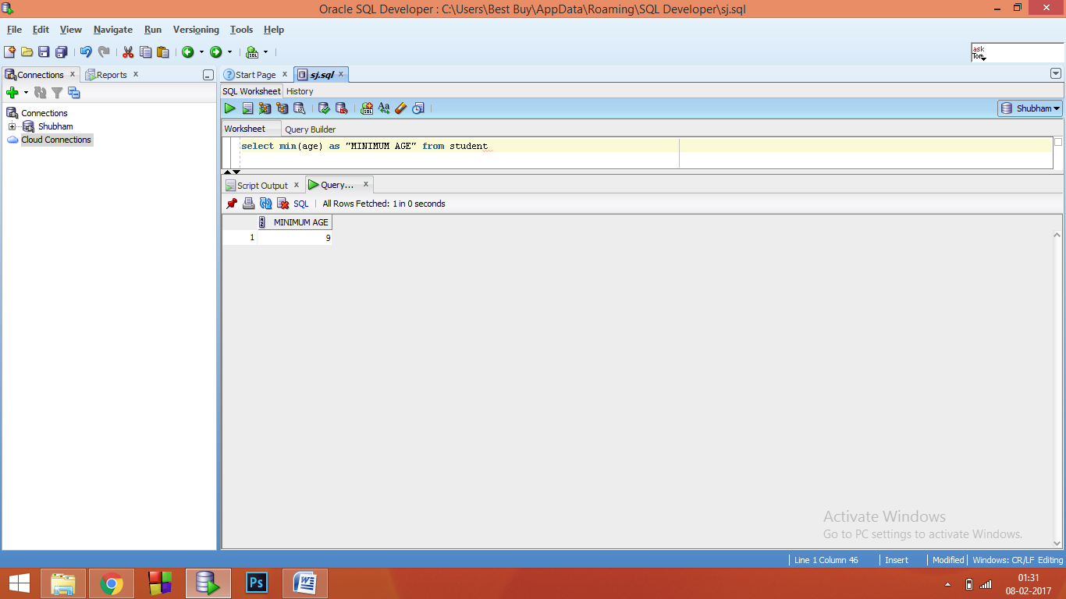

7.5) SUM( ) - select sum(cg) as "TOTAL CG" from student

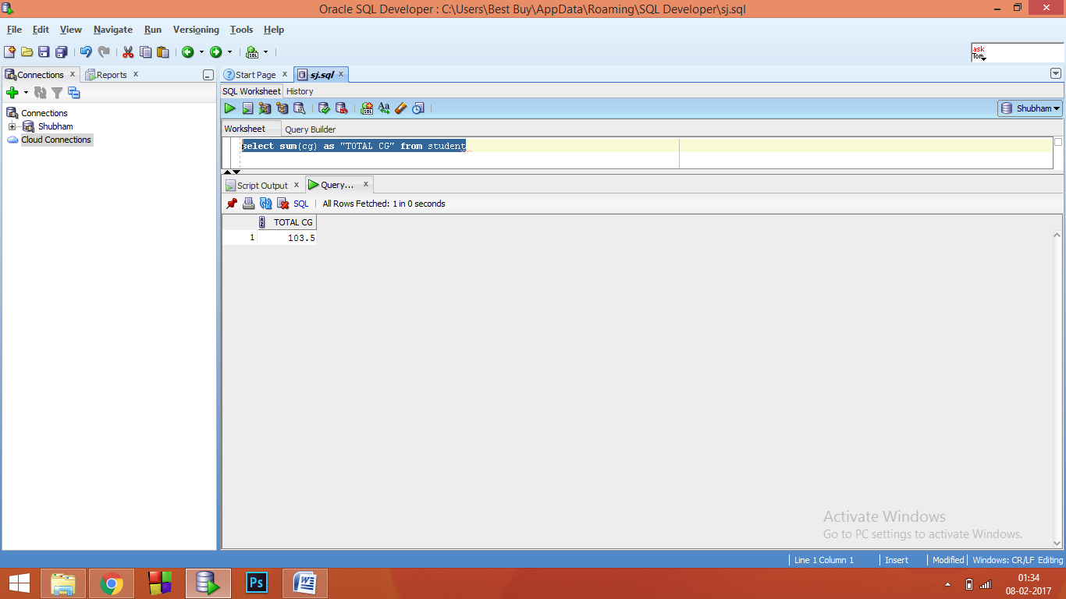

1. NUMERIC FUNCTIONS:

8.1) ABS( ) - select abs(-5) from student where roll_no = 46

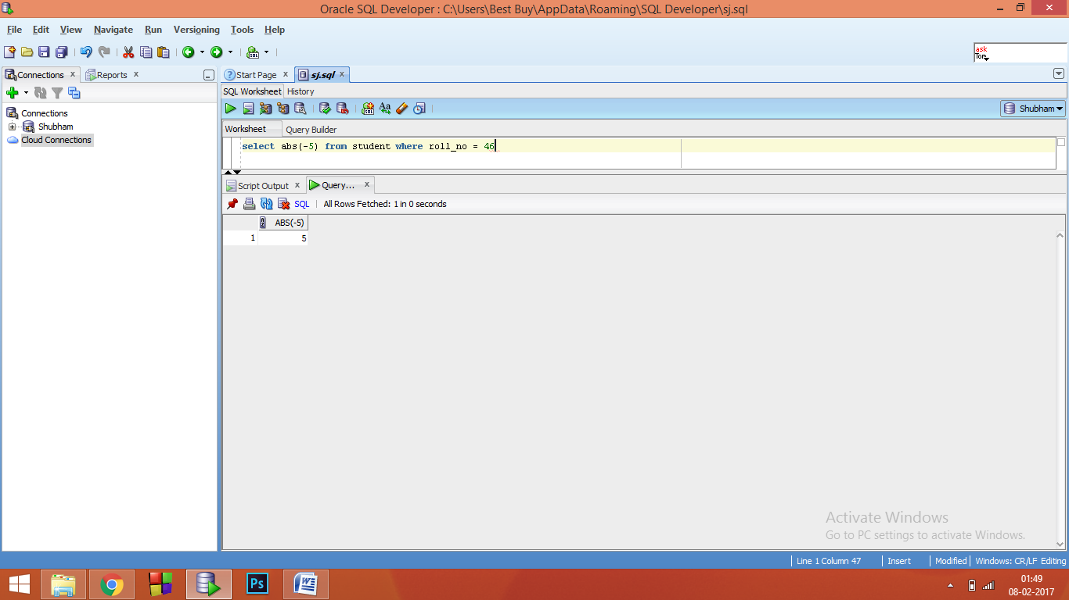

8.2) POWER( ) - select power(3,2) from student where roll_no = 46

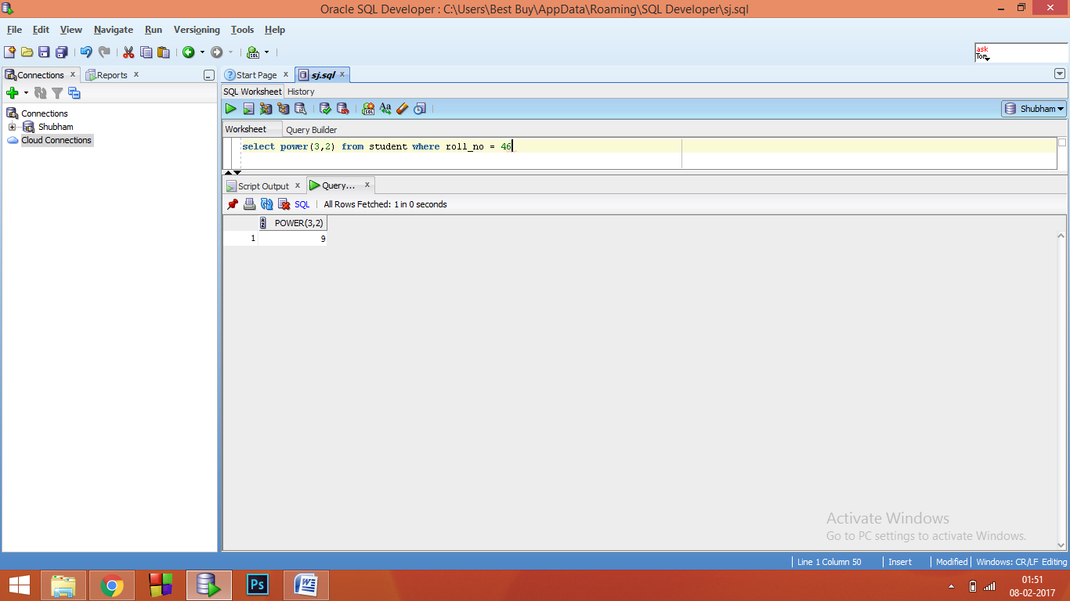

8.3) ROUND( ) - select round(93.12345,-1) from student where roll_no = 46

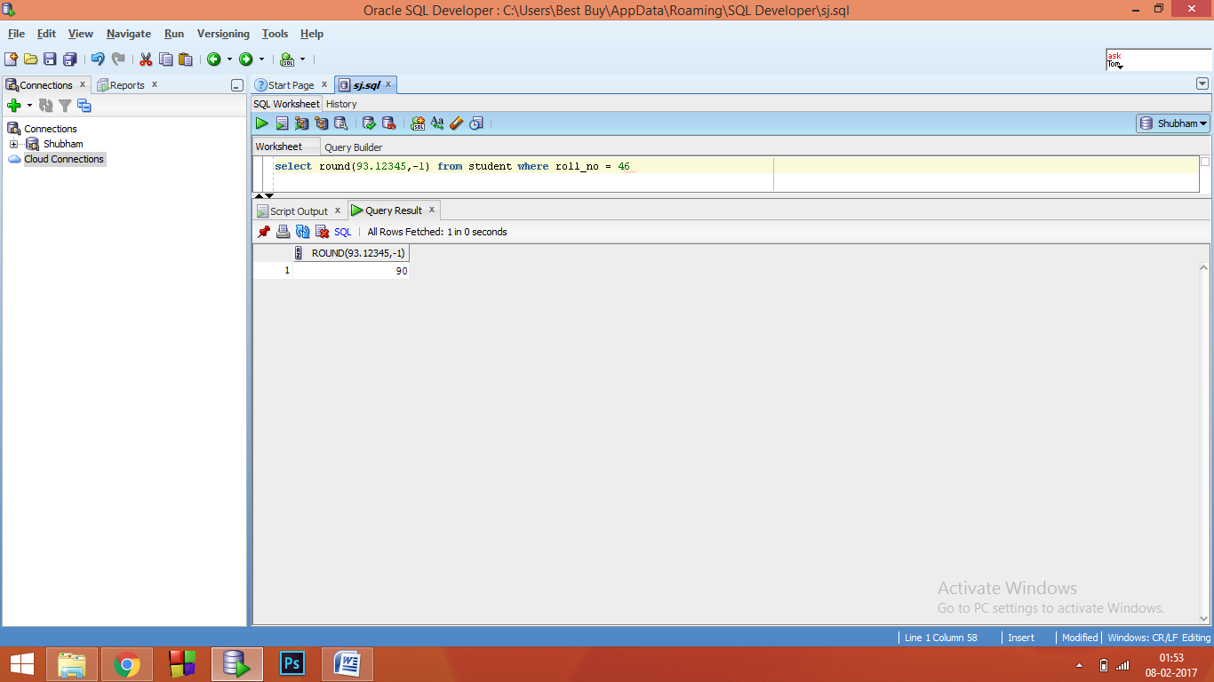

8.4) SQRT( ) - select sqrt(30) from student where roll_no = 46

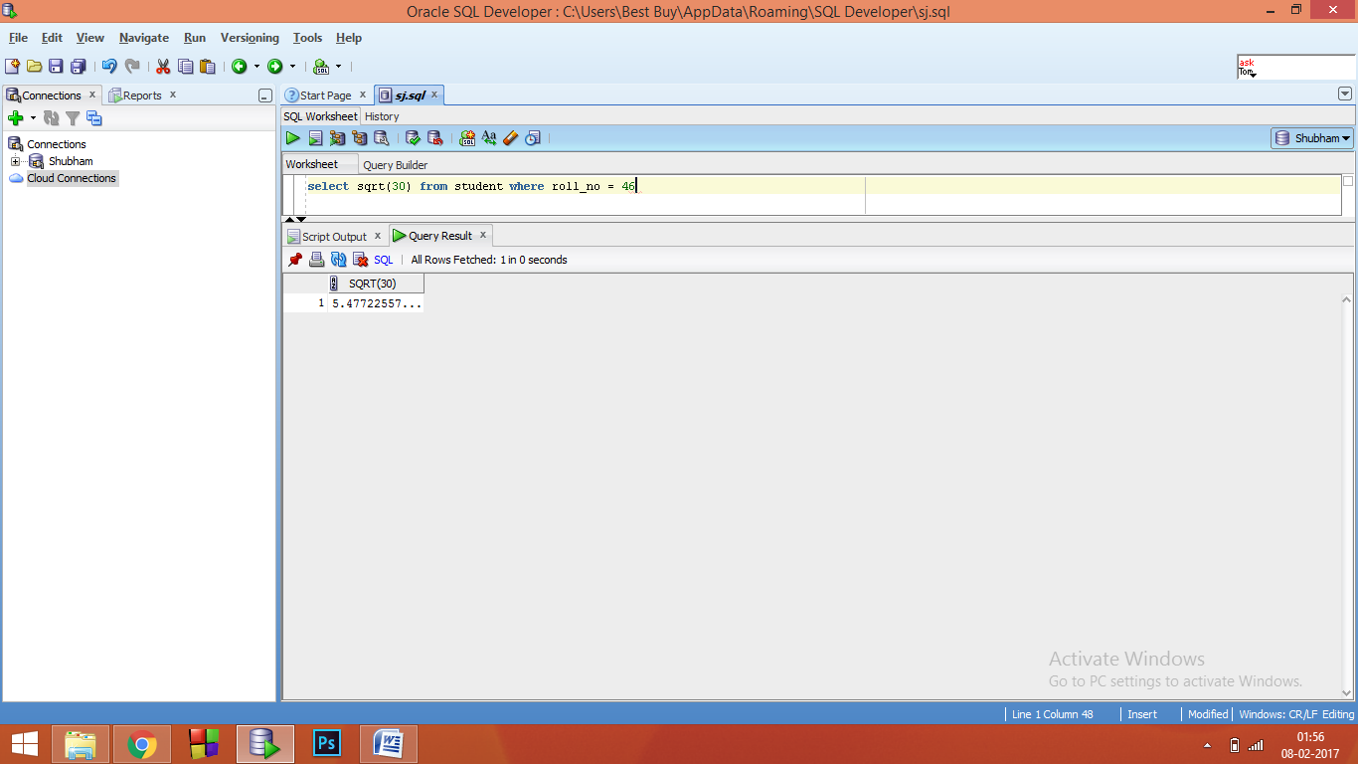

**Lab 4**

**Aim:** Implementation of STRING FUNCTIONS using SQL commands and queries.

**Software Used**: Oracle 12c SE

**Queries: STRING FUNCTIONS:**

1. **Lower:** This returns the argument in lowercase.

**SYNTAX:** select lower(string) from <table_name>

**EXAMPLE:** select lower(NAME) from student

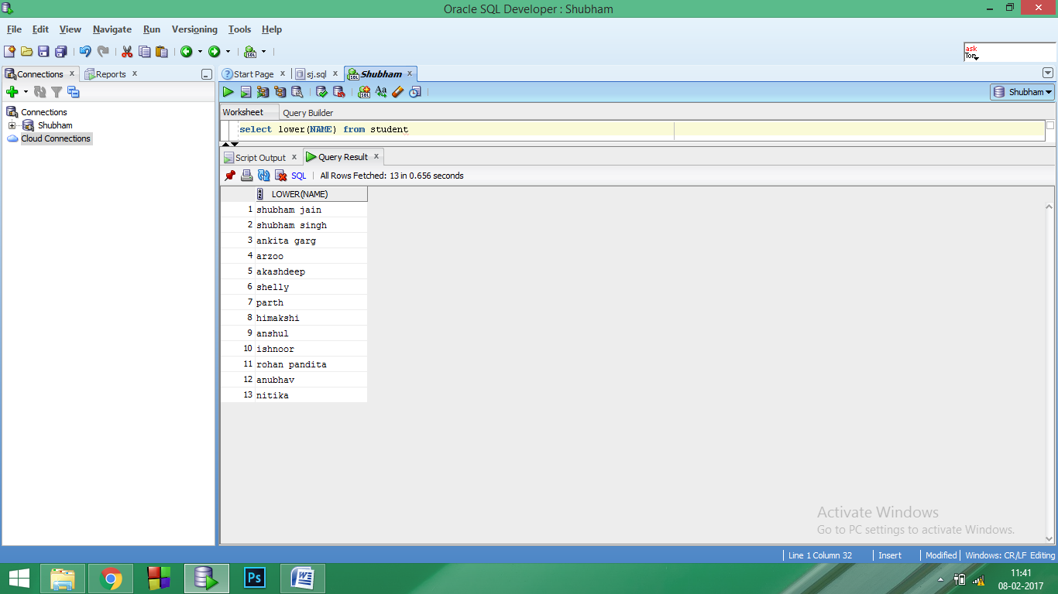

1. **Upper:** This returns the argument in Uppercase.

**SYNTAX:** select upper(string) from <table_name>

**EXAMPLE:**  select upper(NAME) from student

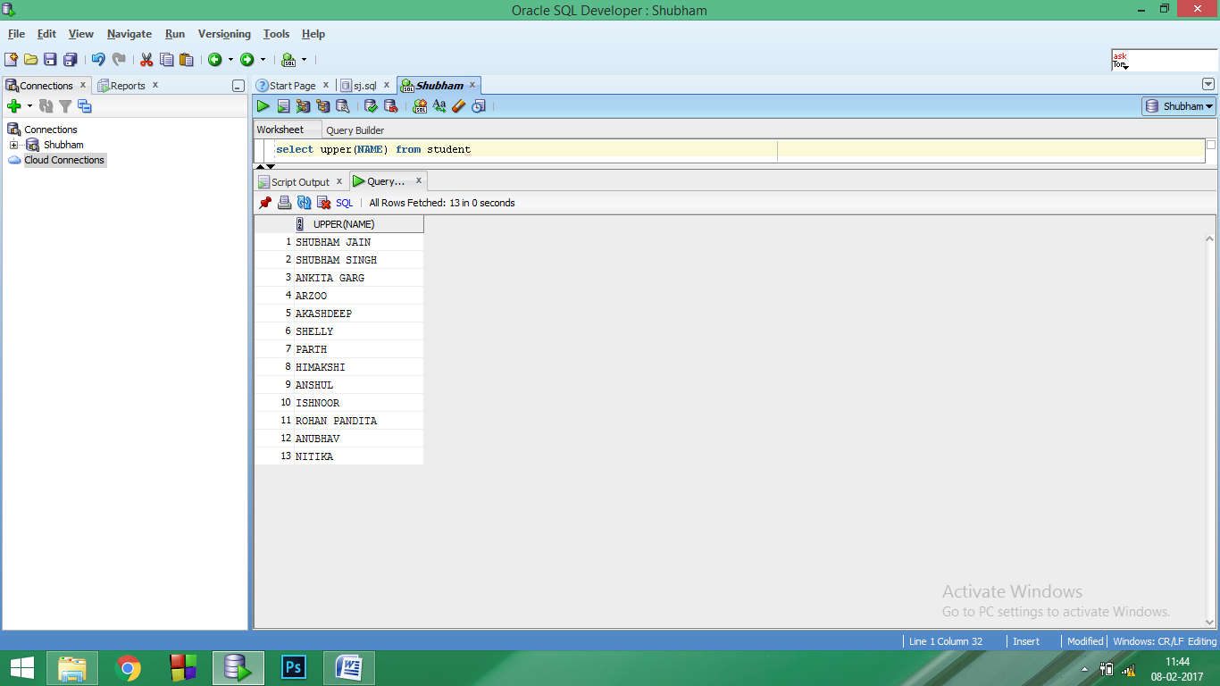

1. **Initcap:** This returns the argument with only the first letter Capitalised

**SYNTAX:** select initcap(string) from <table_name>

**EXAMPLE:** select initcap(name) from student where city like 'J%'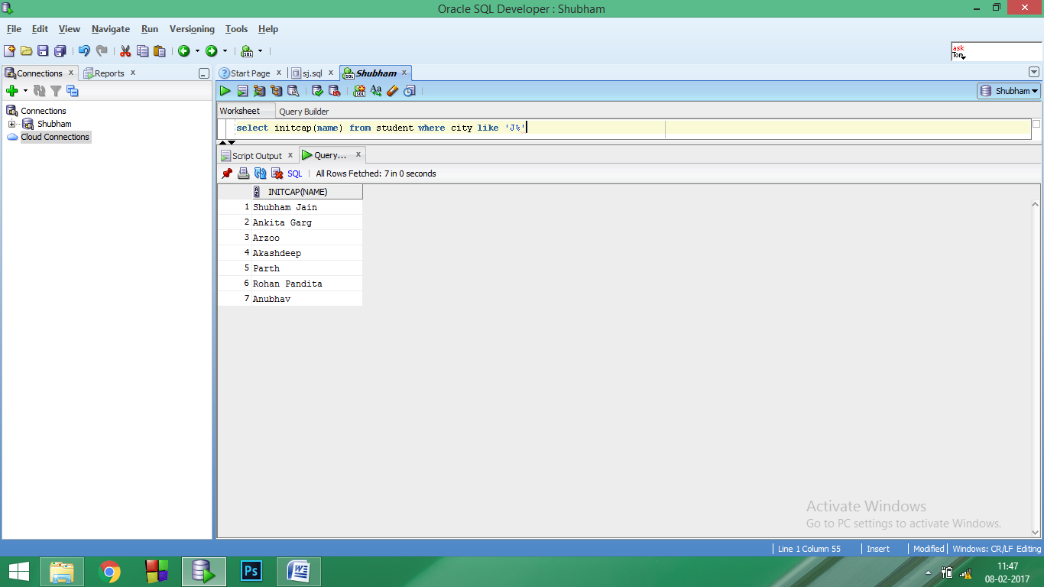

1. **Length:** This returns the length of a string in bytes.

**SYNTAX:** select length(string) from <table_name>

**EXAMPLE:**  select length(city) from student

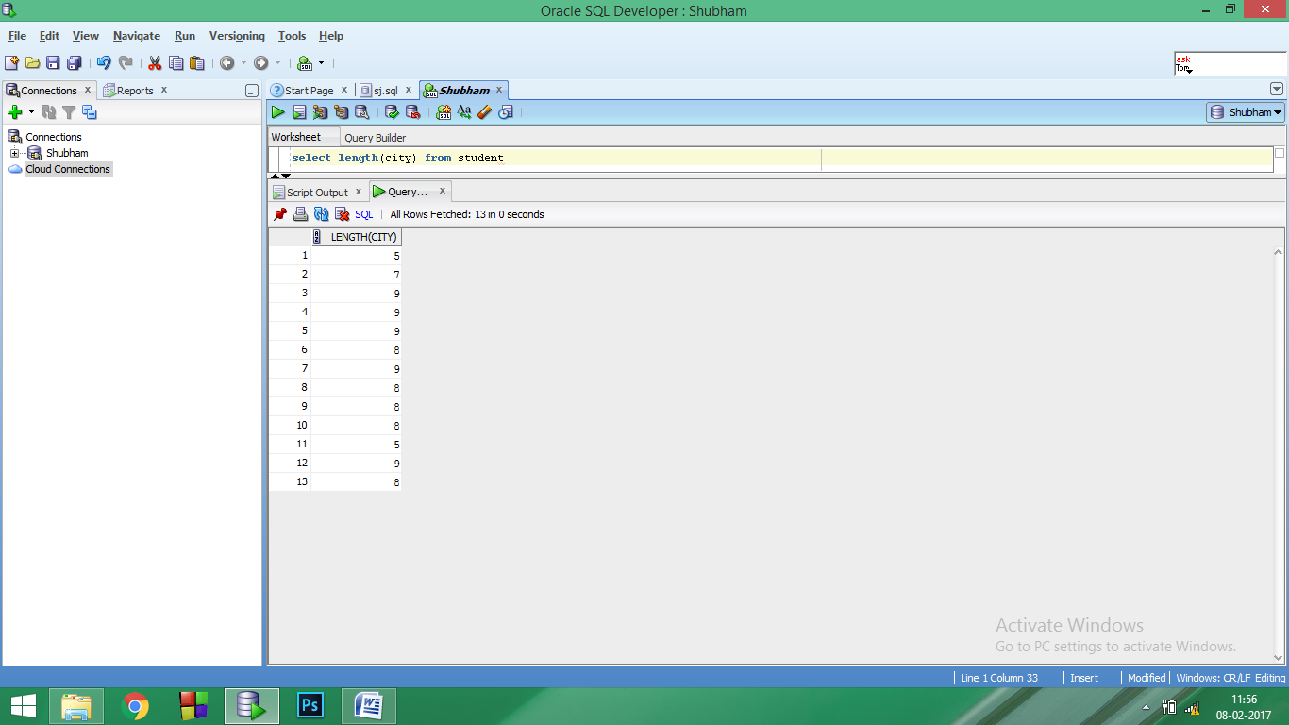

1. **Ltrim:** This removes leading spaces and mentioned characters from the given argument.

**SYNTAX:** select ltrim(string/column_name, characters to be trimmed) from <table_name>

**EXAMPLE:** select ltrim(name,'Sh') from student where name like 'Sh%'

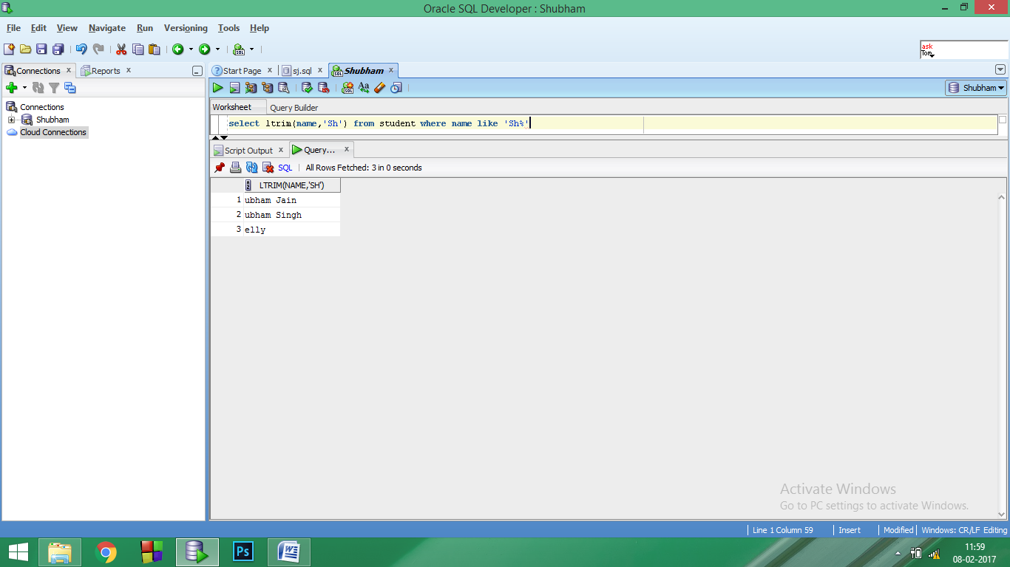

1. **Rtrim:** This removes trailing spaces and mentioned characters from the given argument.

**SYNTAX:** select rtrim(string/column_name, characters to be trimmed) from <table_name>

**EXAMPLE:**  select rtrim(college,'J ') from student

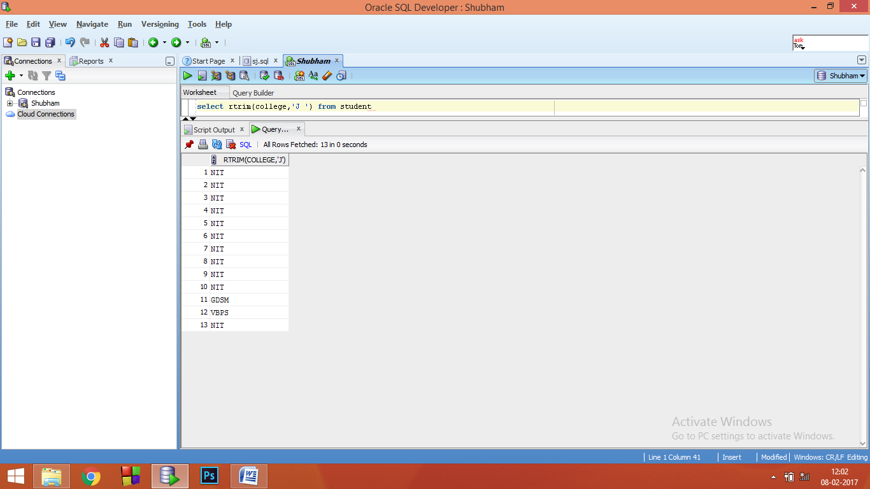

1. **Lpad:** This returns the string argument, left-padded with the specified string.

**SYNTAX:** select lpad(string,size to be padded, padding character) from <table_name>

**EXAMPLE:**  select distinct lpad(city,10,'&') from student

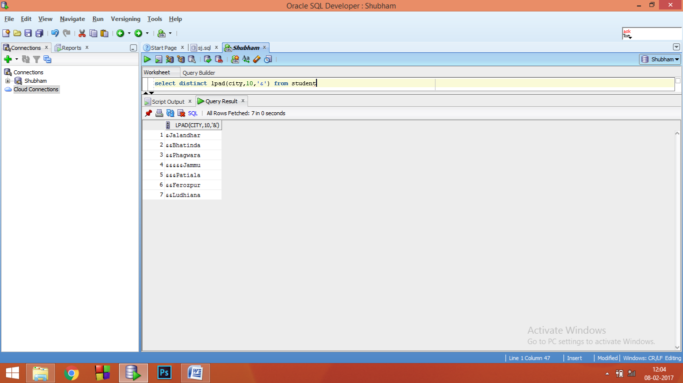

1. **Rpad:** This returns the string argument, right-padded with the specified string.

**SYNTAX:** select rpad(string,size to be padded, padding character) from table_name

**EXAMPLE:**  select rpad(name,22,'&') from student where age<19

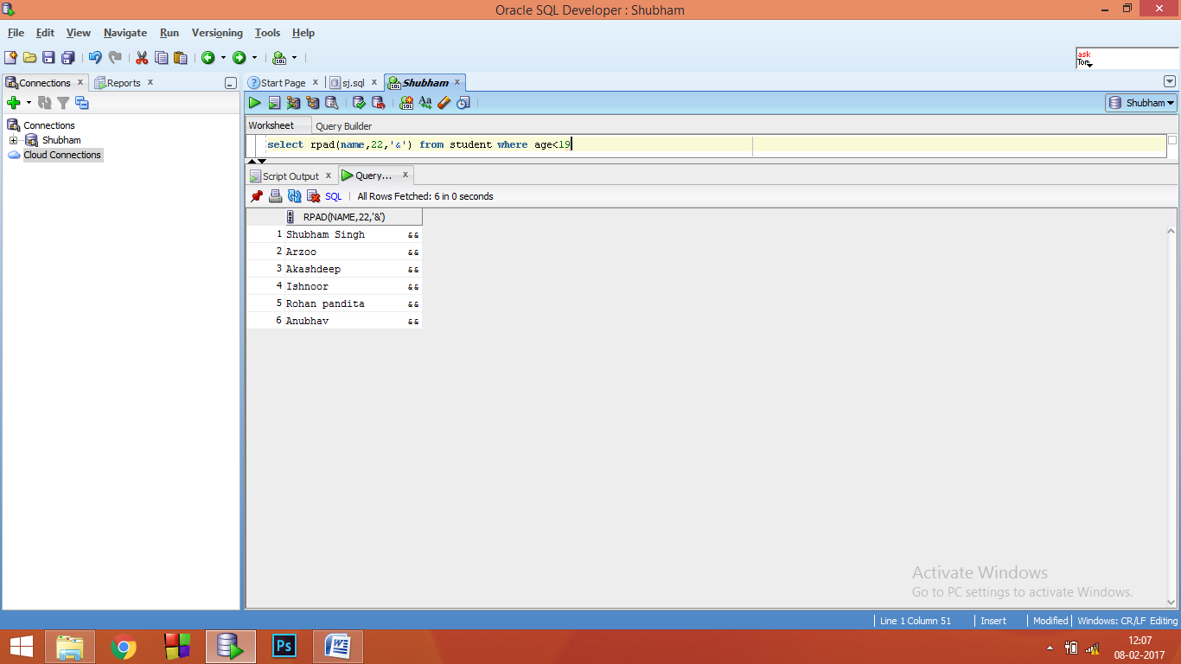

1. **Substr:** This returns the substring as specified

**SYNTAX:** select lpad(string,starting point, number of characters) from <table_name>

**EXAMPLE:**  select substr(name,3,8) from student where age<19

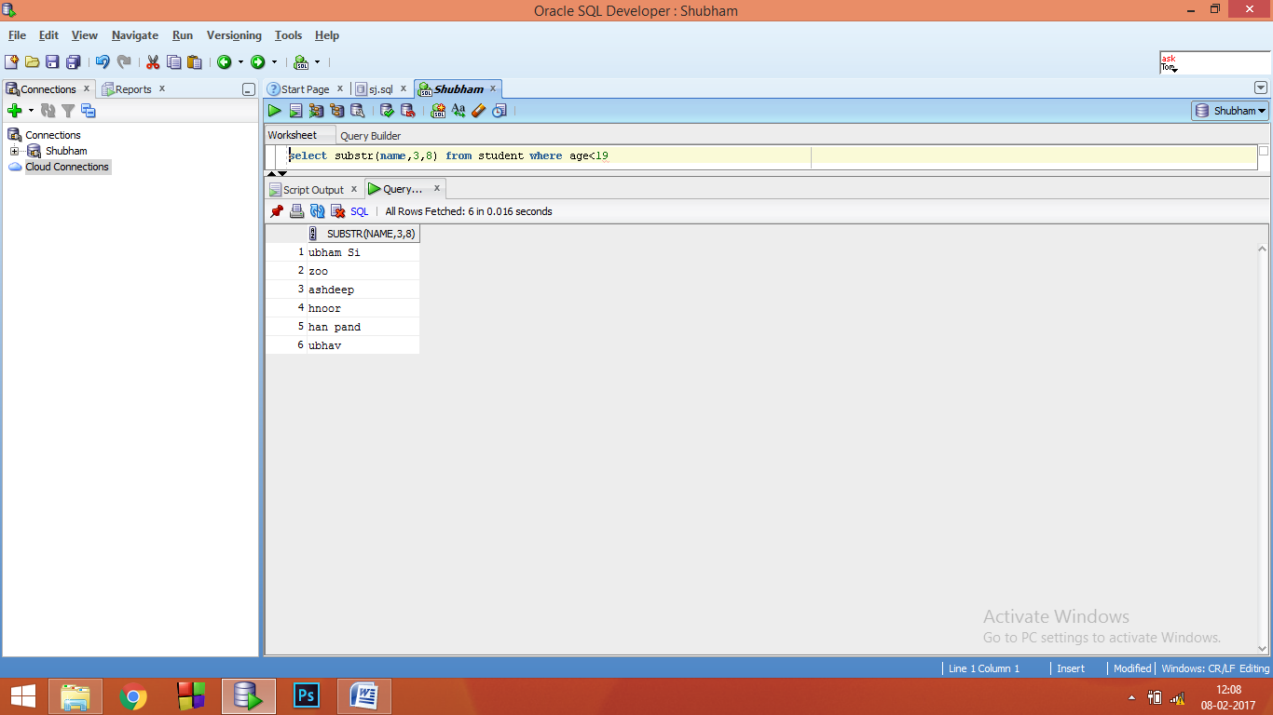

**Lab 5**

**Aim:** To Apply the below mentioned CONSTRAINTS on new as well as already existing tables using SQL commands and queries:

NOT NULL, UNIQUE, PRIMARY KEY, FOREIGN KEY.

Also, drop these constraints when used.

**Software Used**: Oracle 12c SE

**Theory: CONSTRAINTS:** SQL constraints are used to specify rules for the data in a table. If there is any violation between the constraint and the data action, the action is aborted by the constraint. These can be specified when the table is created or after the table is created.

1. **Not Null:** This constraint enforces a column to NOT accept NULL values.
2. **Unique:** This constraint uniquely identifies each record in a database table. A table can have many UNIQUE constraints.
3. **Primary Key:** The PRIMARY KEY constraint uniquely identifies each record in a database table. These must contain UNIQUE values. A primary key column cannot contain NULL values. Most tables should have a primary key, and each table can have only ONE primary key.
4. **Foreign Key:** A FOREIGN key in one table points to a PRIMARY KEY in another table. This constraint is used to prevent actions that would destroy links between tables. This constraint also prevents invalid data from being inserted into the foreign key column, because it has to be one of the values contained in the table it points to.

**Queries:**

1. Add a PRIMARY KEY, NOT NULL constraint at the time of creation of table :

create table Results(Roll_no int PRIMARY KEY, Department varchar(10) NOT NULL, CG float(4))

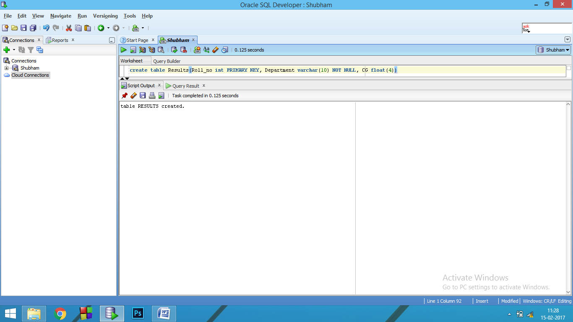

1. Add a PRIMARY KEY after the creation of table using ALTER:

ALTER TABLE results add CONSTRAINT P_Key PRIMARY KEY(Roll_No)

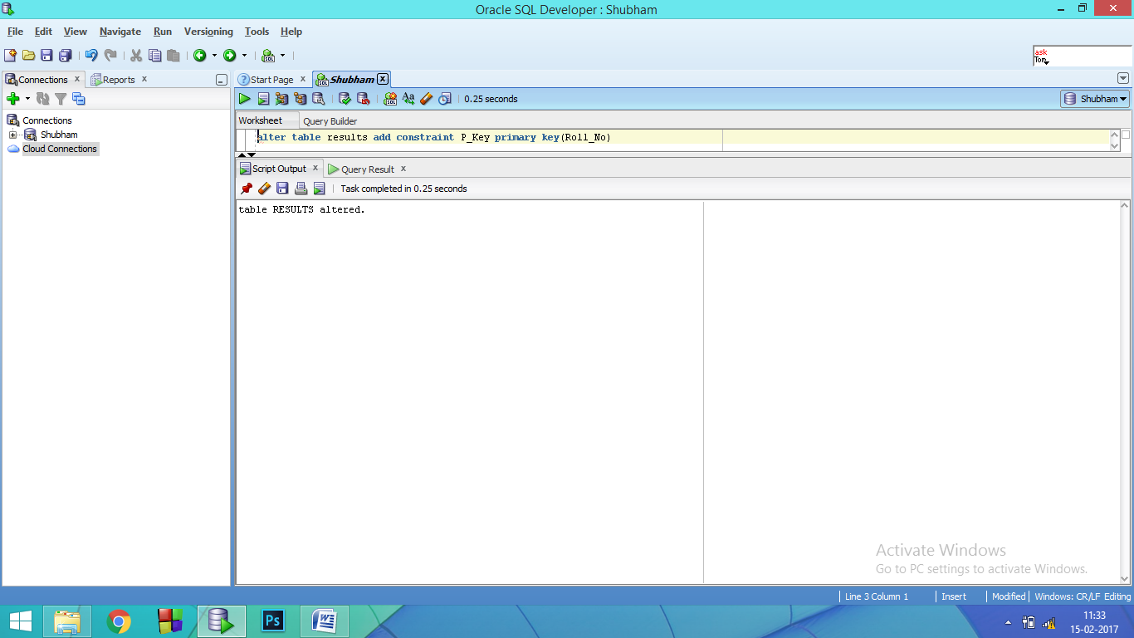

1. Drop a PRIMARY KEY constraint :

ALTER TABLE results DROP CONSTRAINT P_Key

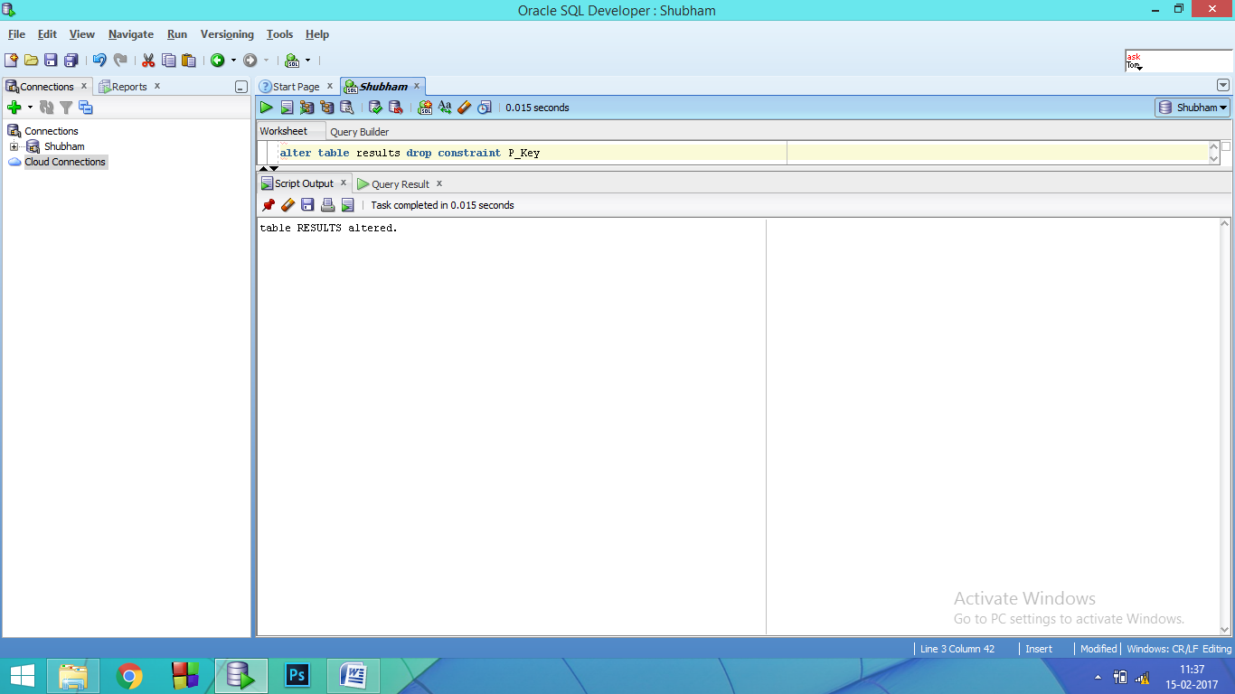

1. Inserting some Duplicate values in the Primary Key Constraint:

insert into student values('Varun',15103038,10,'M','Jammu','NITJ')

// here roll_no was the primary key and 15103038 was already a value in it.

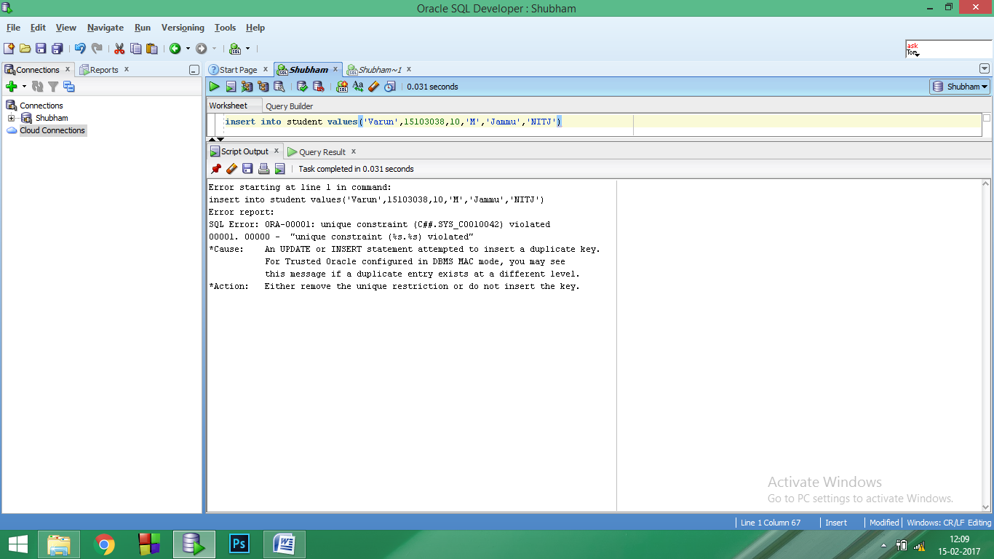

1. Add a FOREIGN KEY constraint on a table at the time of creation:

create table Results(Roll_no int , Department varchar(10) NOT NULL, CG float(4),CONSTRAINT F_key FOREIGN KEY(Roll_no) REFERENCES student(Roll_no))

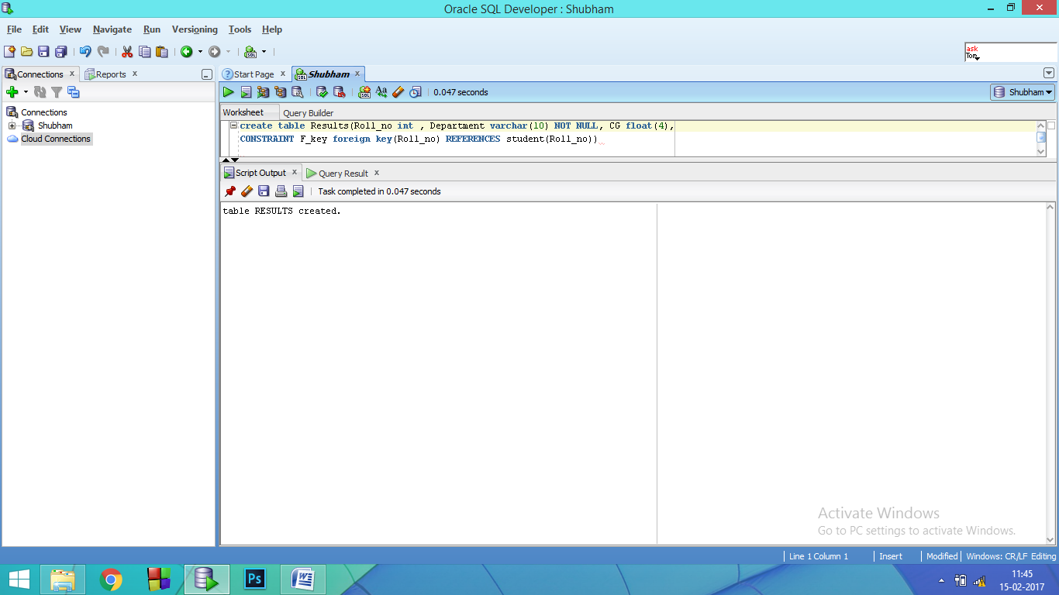

1. Try inserting various values in the table Results :

insert into results values(15103038,'CSE', 7.65)

insert into results values(15103010,'CSE', 6.65)

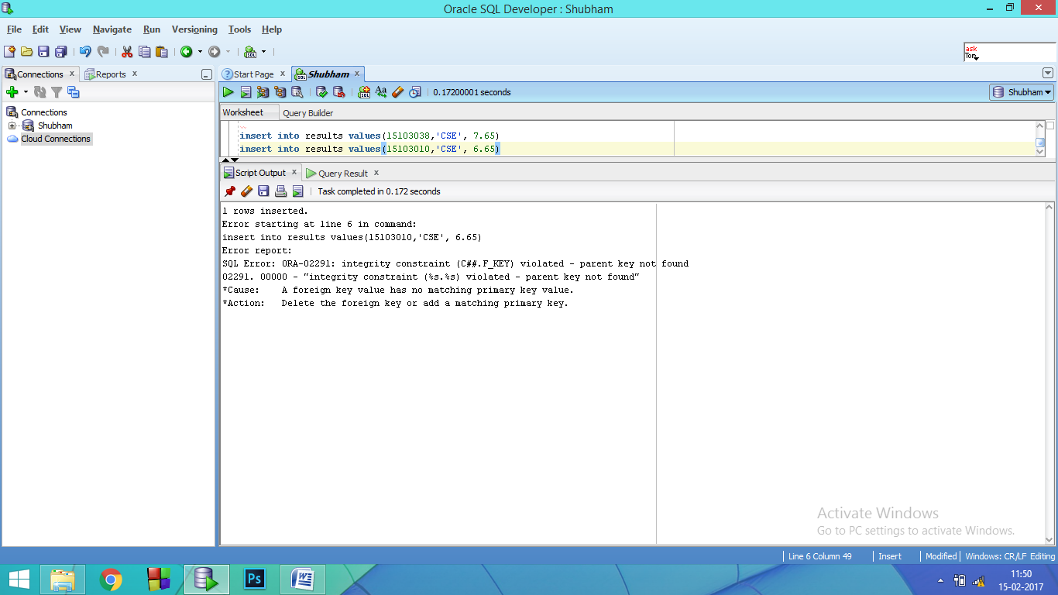

1. Try deleting some values in the Parent table :

delete from student where roll_no=15103061

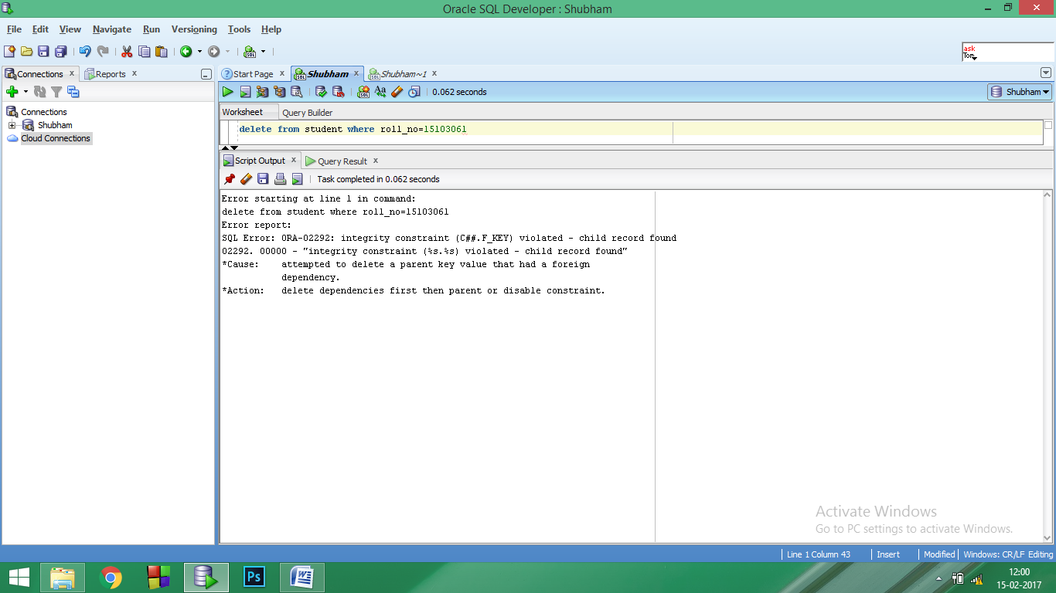

1. Try deleting some values in the Child table :

delete from student where roll_no=15103021

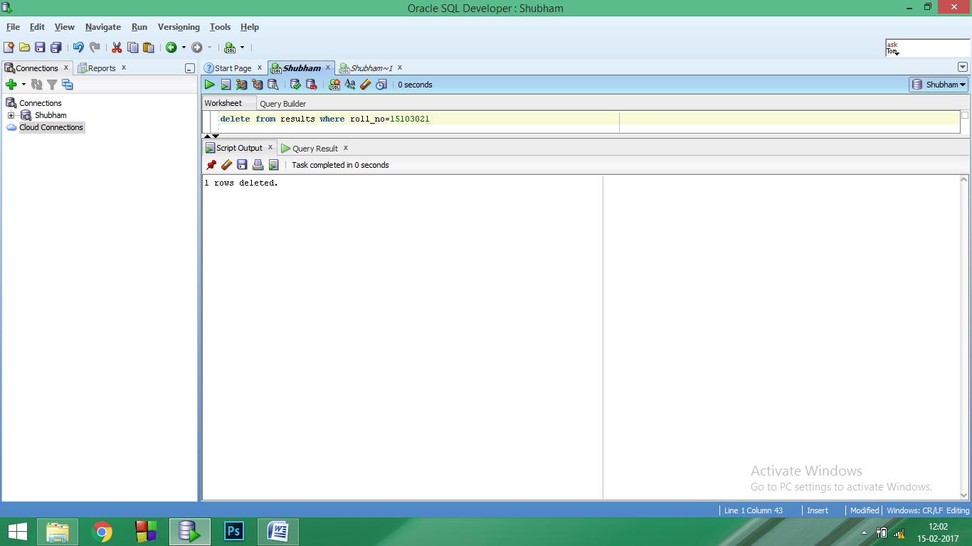

This shows after applying the FOREIGN KEY constraint we can delete anything from the Child table but not from the Parent Table since the reference is from the Parent to the Child.

**Lab 6**

**Aim:** To Apply the FOREIGN KEY CONSTRAINT on SQL queries:

1. On delete CASCADE
2. On delete Set NULL
3. Enable and disable constraint.

**Software Used**: Oracle 12c SE

**Theory:**

**FOREIGN KEY WITH:**

1. **ON DELETE CASCADE:** A foreign key with cascade delete means that if a record in the parent table is deleted, then the corresponding records in the child table will automatically be deleted. A foreign key with cascade delete can be created using either a CREATE Table statement or an ALTER table statement.
2. **ON DELETE SET NULL:** A foreign key with “SET NULL on delete” means that if a record in the parent table is deleted then the corresponding records in the chils table will have the foreign key fields set to NULL. The records in the child table will not be deleted. It can also be done in two ways either a CREATE Table statement or an ALTER table statement.

**Queries:**

1. Applying ON DELETE CASCADE with the foreign key on an existing table.

ALTER TABLE results ADD CONSTRAINT F_key FOREIGN KEY(roll_no) REFERENCES student(roll_no) ON DELETE CASCADE.

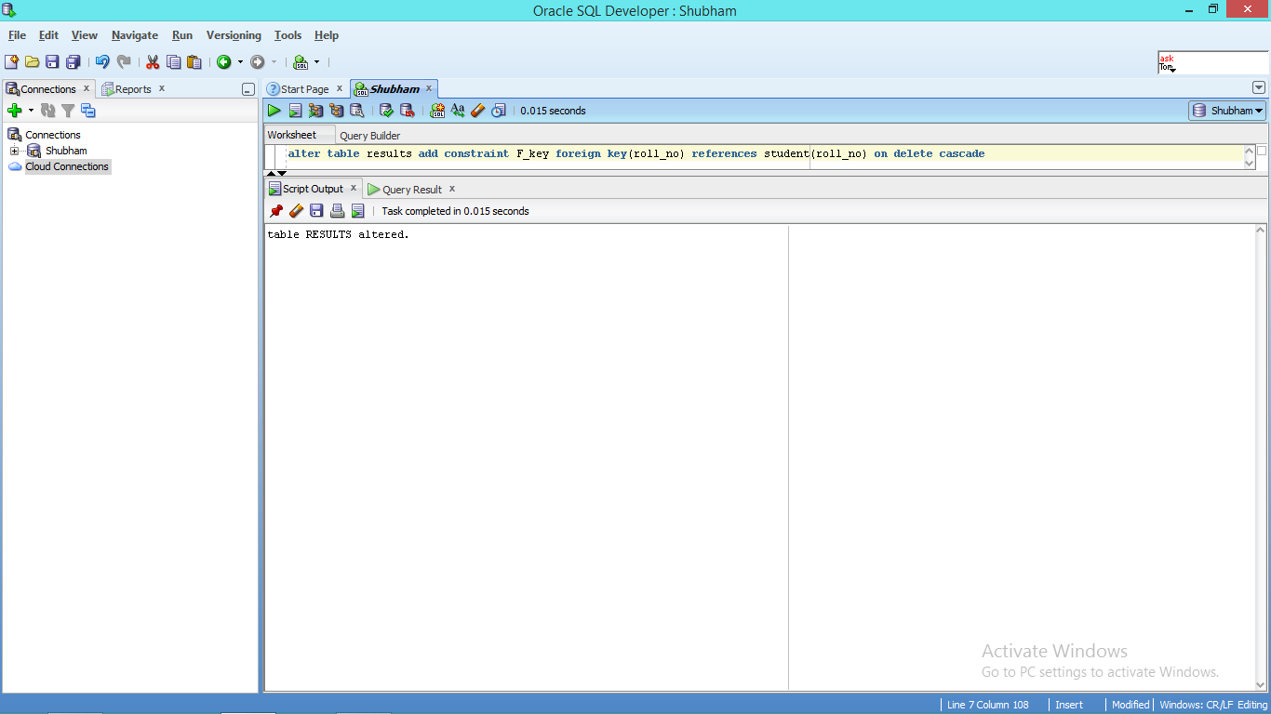

1. Effect of deletion from parent table on the parent and the child table.

**BEFORE:**

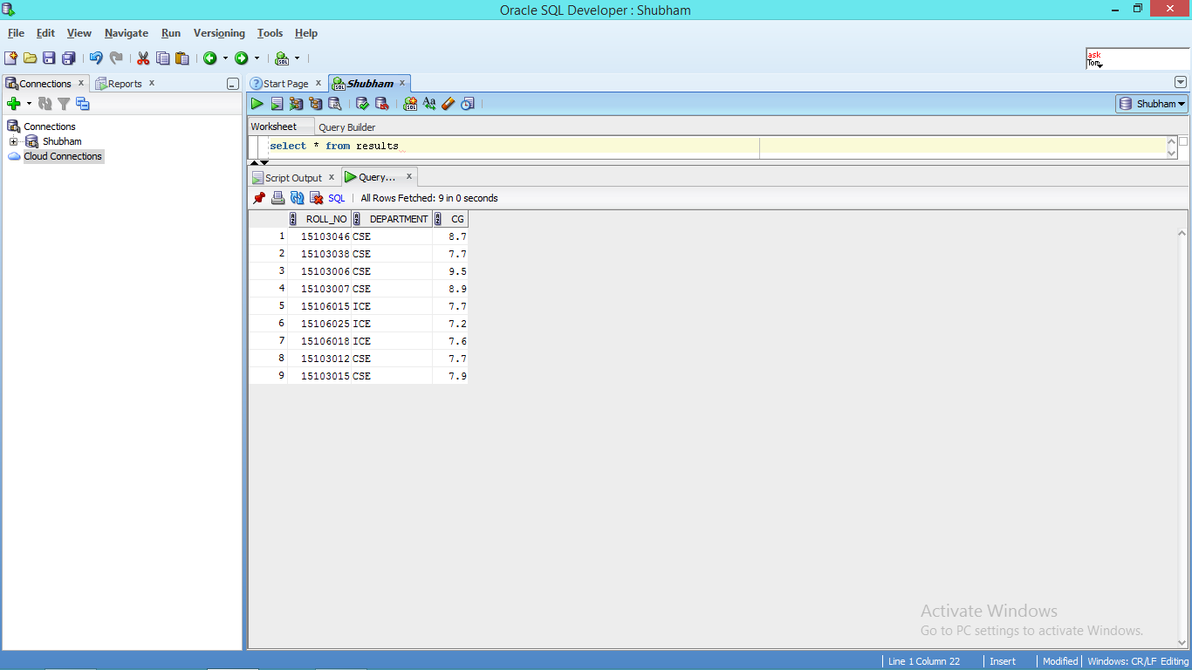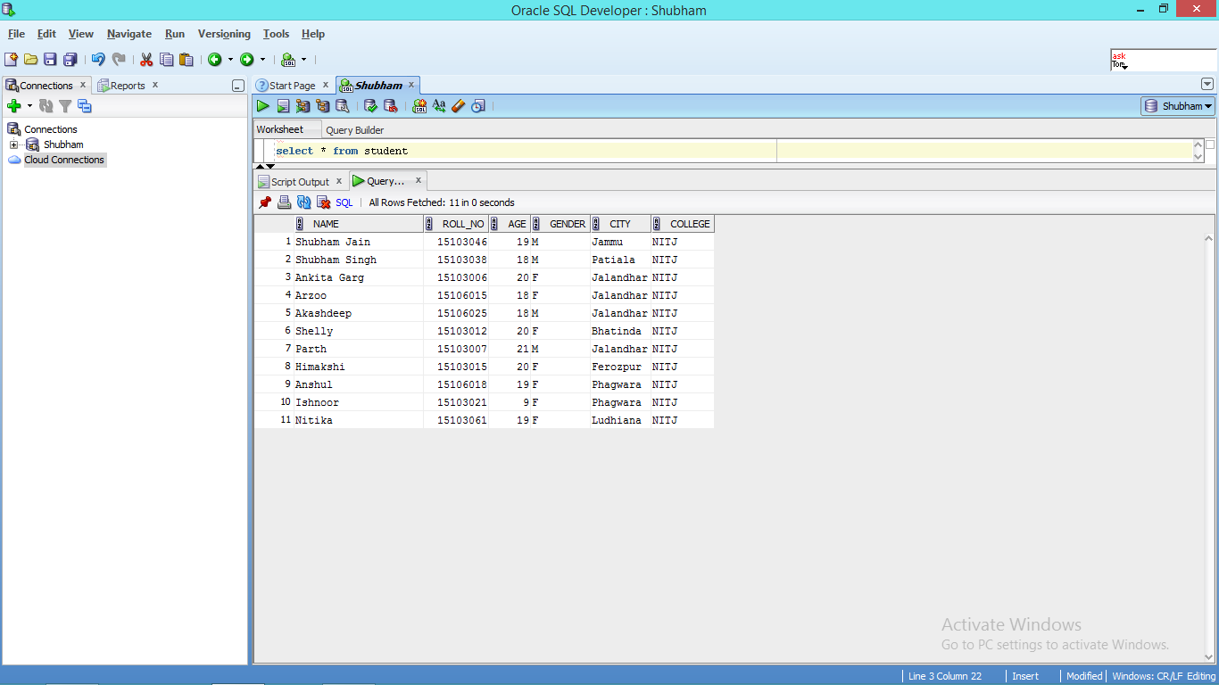 Parent Table

Child table

* Deletion:

delete from student where roll_no =15103012

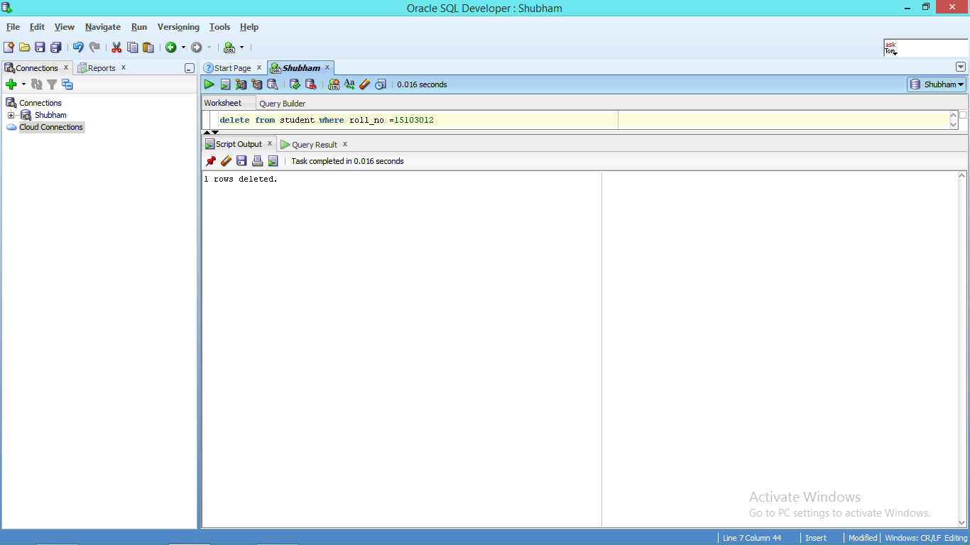

**AFTER:**

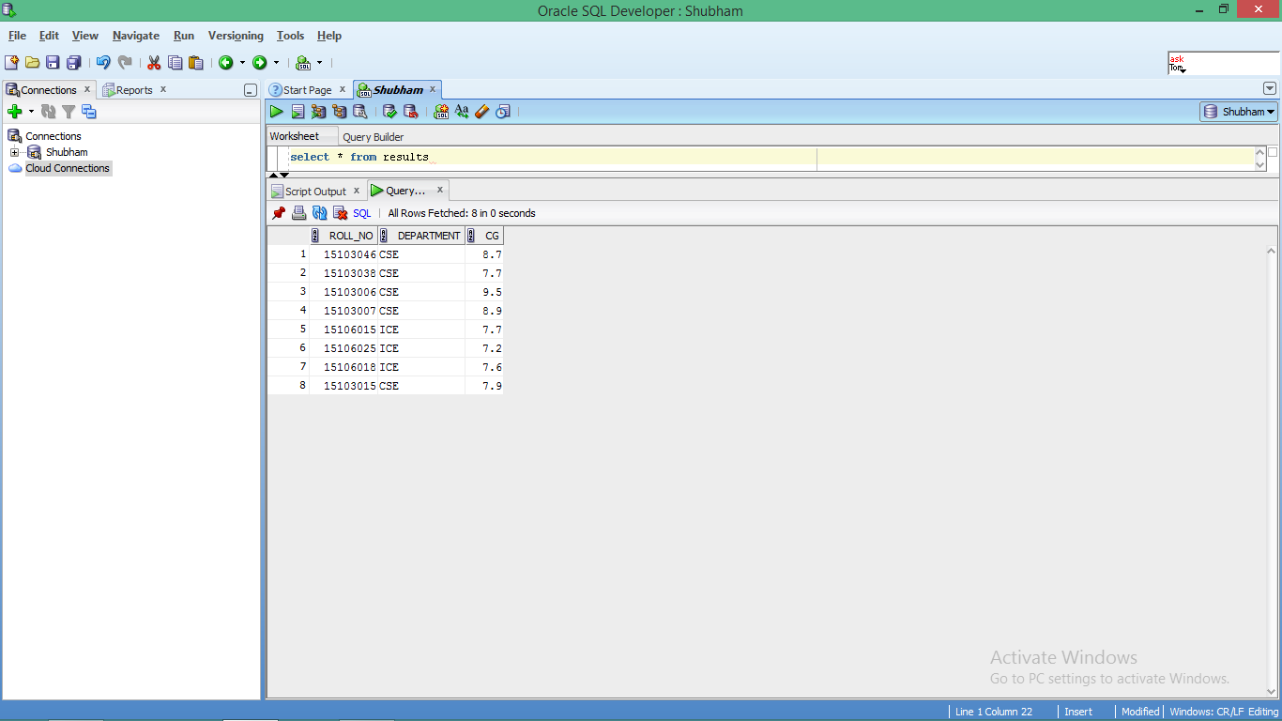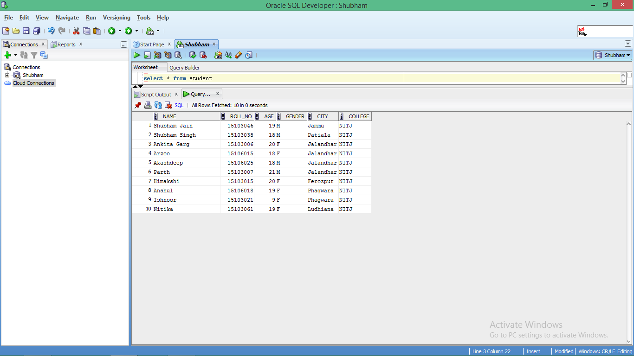

Parent table Child table

It is seen that the record of 15103012 is deleted from both the parent as well as child table

1. Dropping the constraint:

alter table results drop constraint F_key

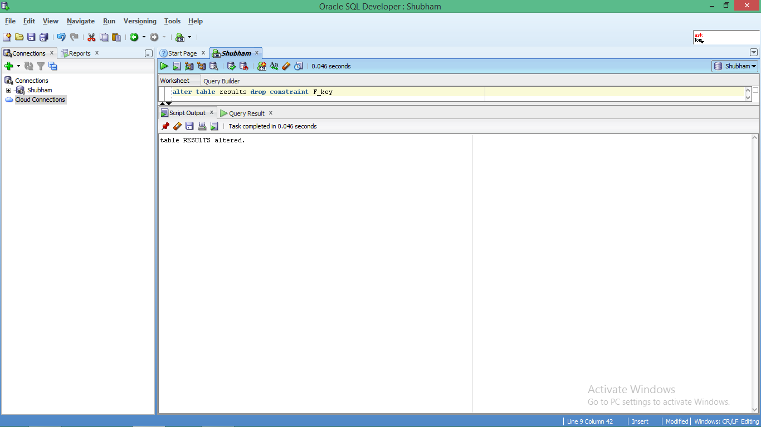

1. Applying ON DELETE SET NULL with the foreign key on an existing table.

ALTER TABLE results ADD CONSTRAINT F_key FOREIGN KEY(roll_no) REFERENCES student(roll_no) ON DELETE SET NULL

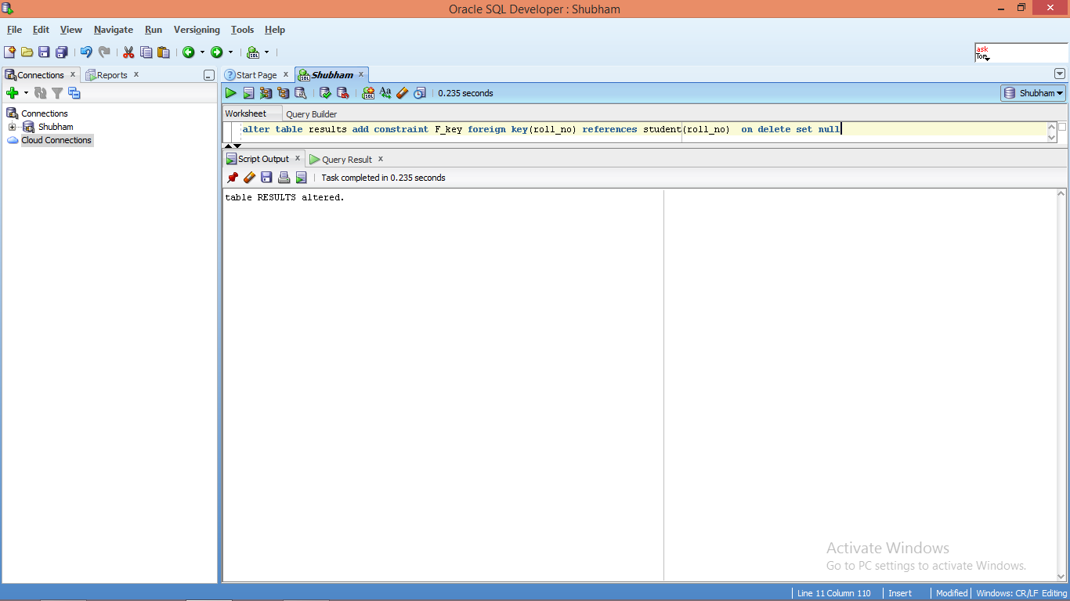.

* Deletion:

delete from student where roll_no =15106025

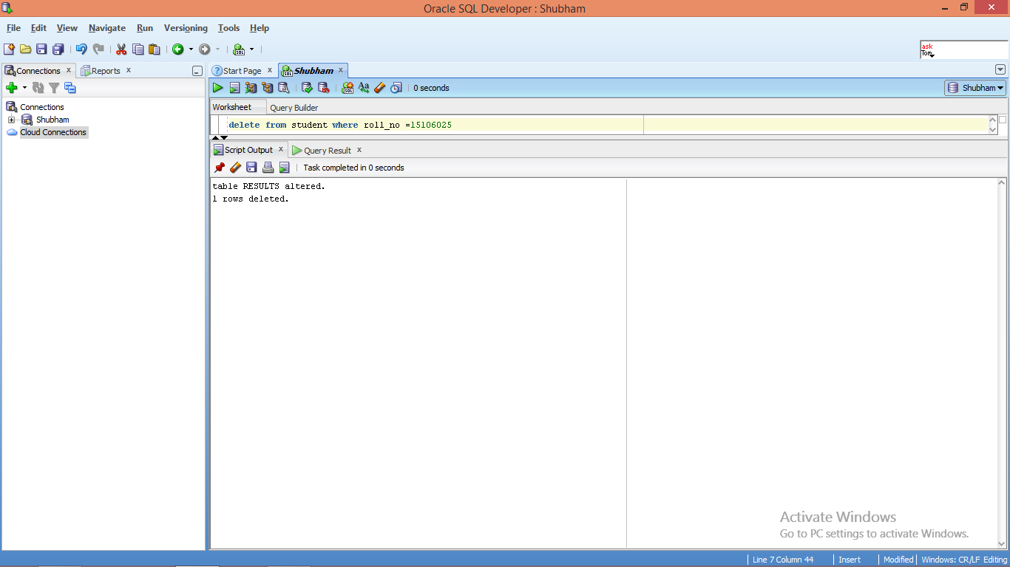

* Effect on Parent and Child Table:

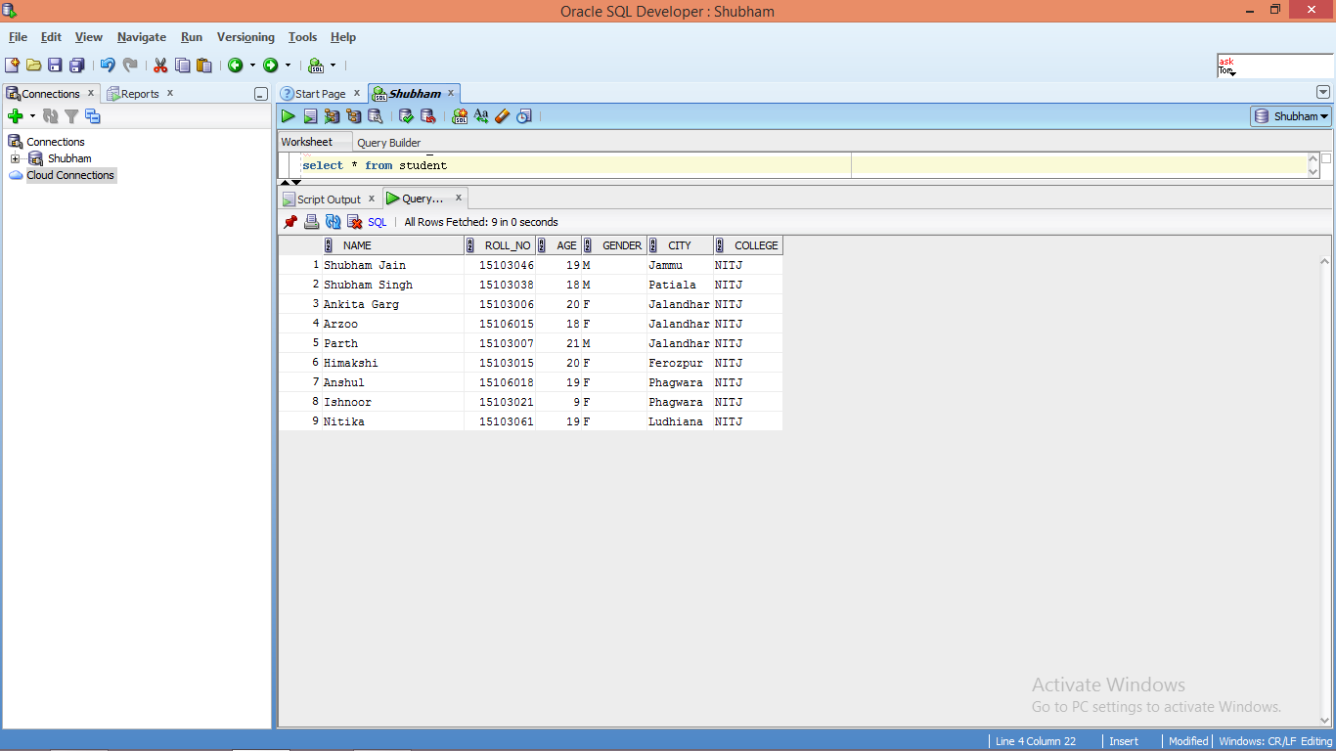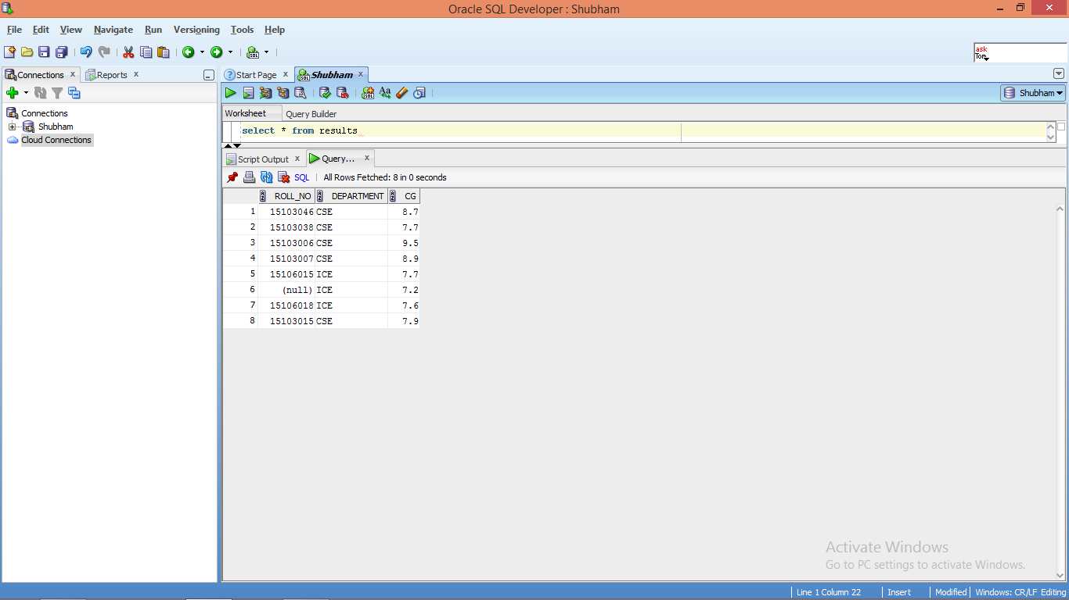

Parent table Child Table

The record is deleted from the parent table but it is set to null in child table.

1. Checking all the available constraints

select * from user_constraints

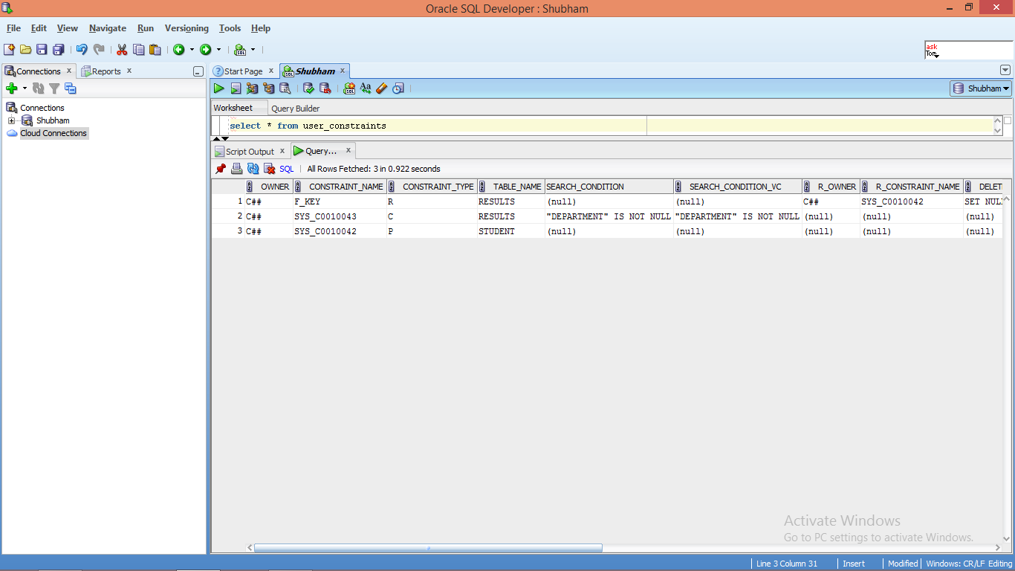

**Lab 7**

**Aim:** To Apply various types of JOINS using SQL queries:

1. Natural Join
2. Inner Join
3. Left Outer Join
4. Right Outer Join
5. Full Outer Join

And perform the following queries:

1. L
2. L
3. L
4. L
5. L
6. L
7. L
8. L
9. L
10. L

**Software Used**: Oracle 12c SE

**Theory: JOINS:** SQL Join is used to fetch data from two or more tables, which is joined to appear as single set of data. SQL Join is used for combining column from two or more tables by using values common to both tables. **Join** Keyword is used in SQL queries for joining two or more tables.

1. **Natural Join :** Natural join compares all the common columns.

**SYNTAX:**

select * from table1 NATURAL JOIN table2.

1. **Inner Join:** Inner Join is the simplest and most common type of join. It is also known as simple join. It returns all rows from multiple tables where the join condition is met.

**SYNTAX:**

select * from table1 INNER JOIN table2 ON t1.column=t2.column

1. **Left Outer Join:** Outer join gives the non-matching records along with matching records. This will display the all matching records and the records which are in left hand side table those that are not in right hand side table.

**SYNTAX:** select columns from table1 LEFT [OUTER] JOIN table2 ON t1.column = t2.column

1. **Right Outer Join:** Outer join gives the non-matching records along with matching records. This will display the all matching records and the records which are in right hand side table those that are not in left hand side table.

**SYNTAX:** select columns from table1 RIGHT [OUTER] JOIN table2 ON t1.column = t2.column

1. **Full Outer Join:** Outer join gives the non-matching records along with matching records. This will display the all matching records and the non-matching records from both tables.

**SYNTAX:** select columns from table1 FULL [OUTER] JOIN table2 ON t1.column = t2.column

**Queries:**

The tables to be used are :-

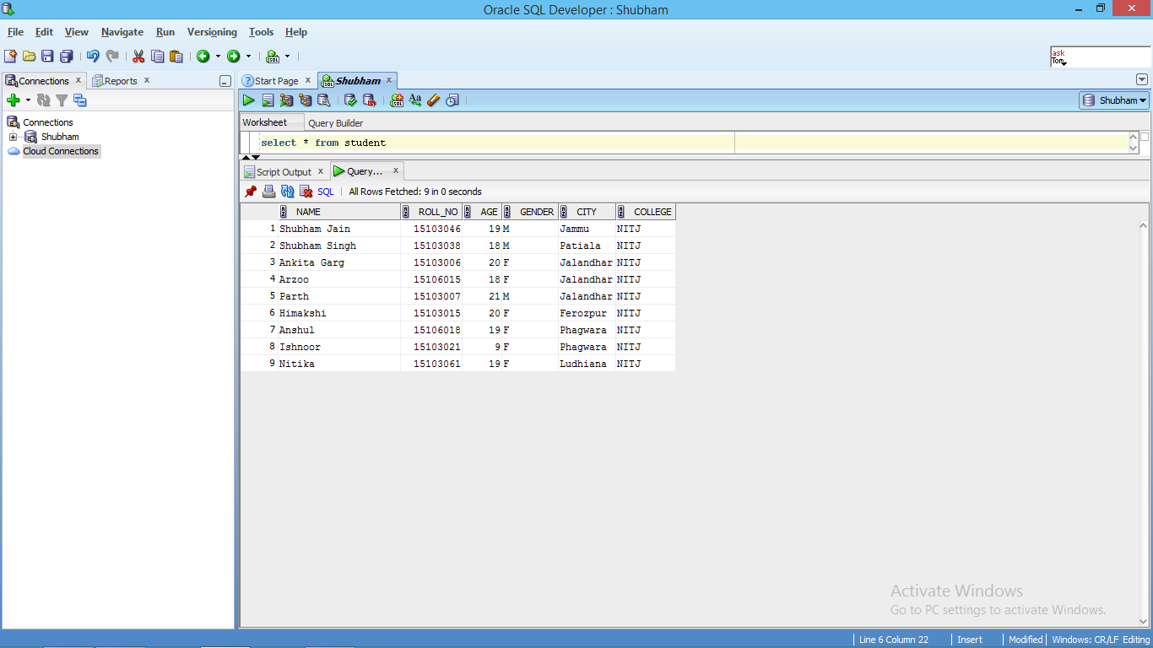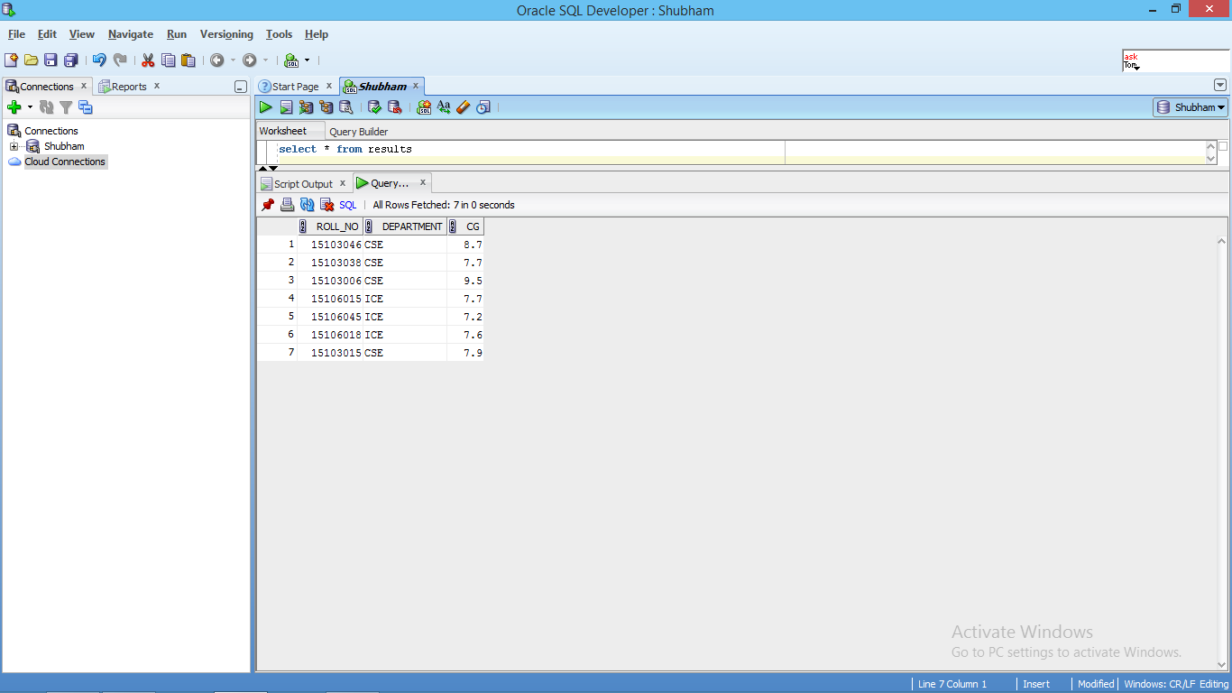

1. NATURAL JOIN :

SELECT * FROM student NATURAL JOIN results

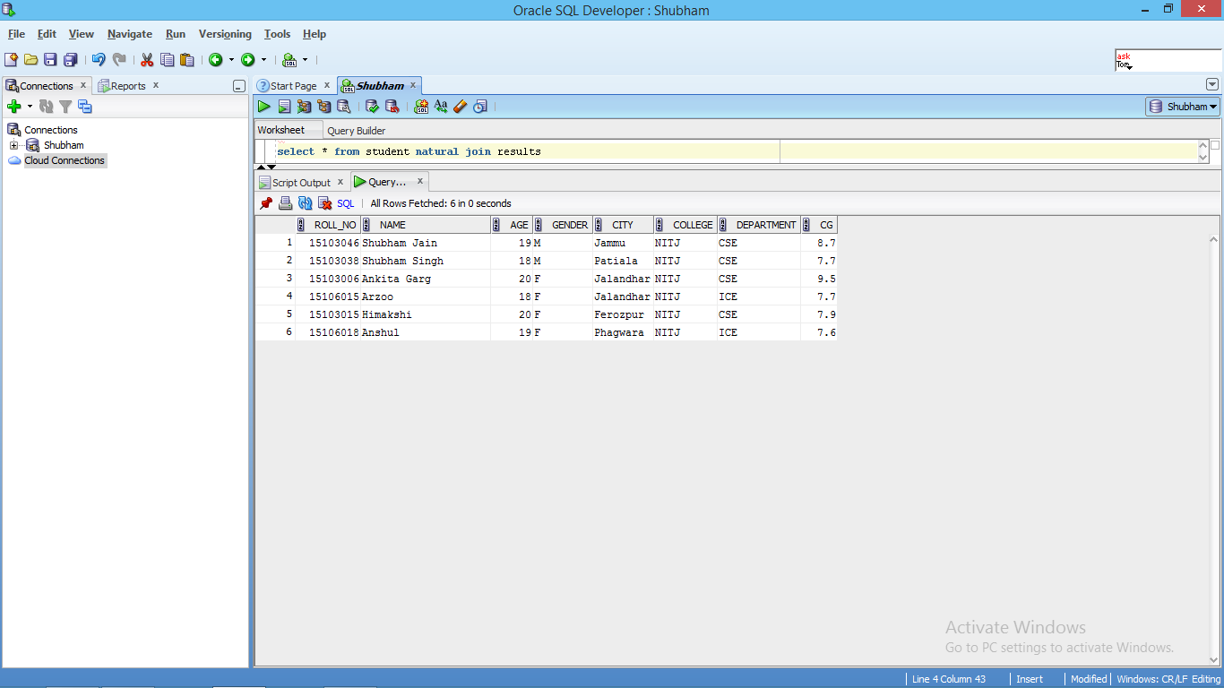

1. INNER JOIN :

SELECT * FROM student INNER JOIN results ON student.roll_no=results.roll_no

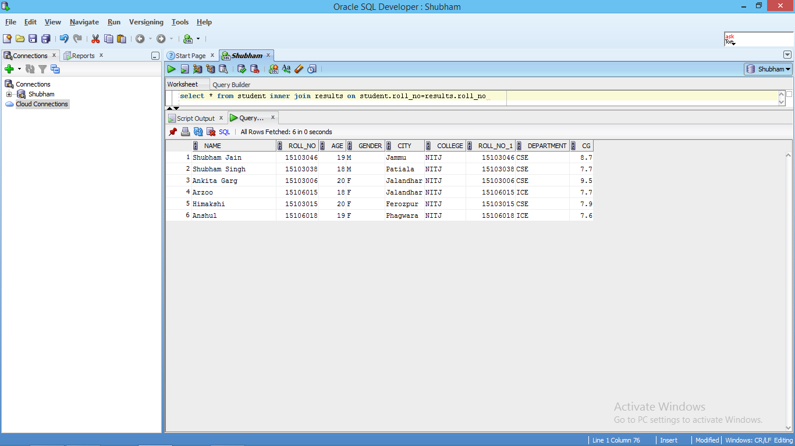

1. LEFT OUTER JOIN :

SELECT * FROM student LEFT OUTER JOIN results ON student.roll_no=results.roll_no

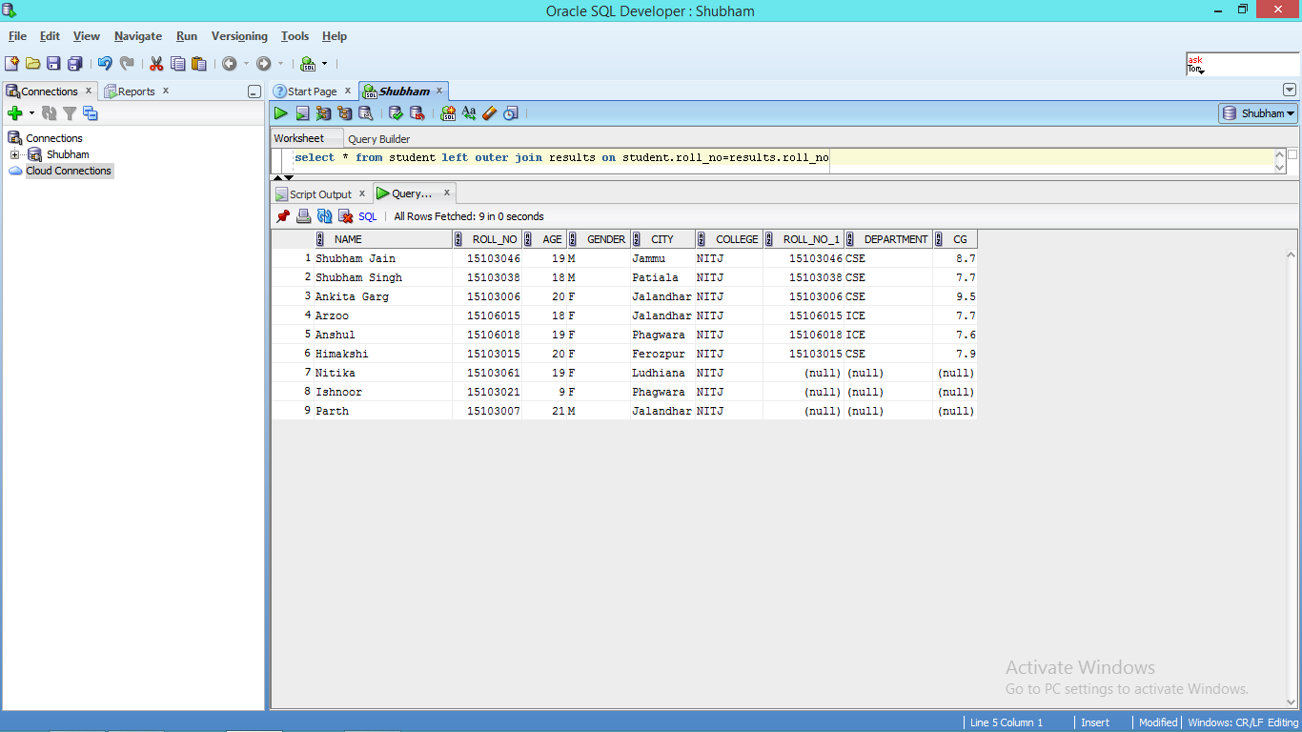

1. RIGHT OUTER JOIN :

SELECT * FROM student RIGHT OUTER JOIN results ON student.roll_no=results.roll_no

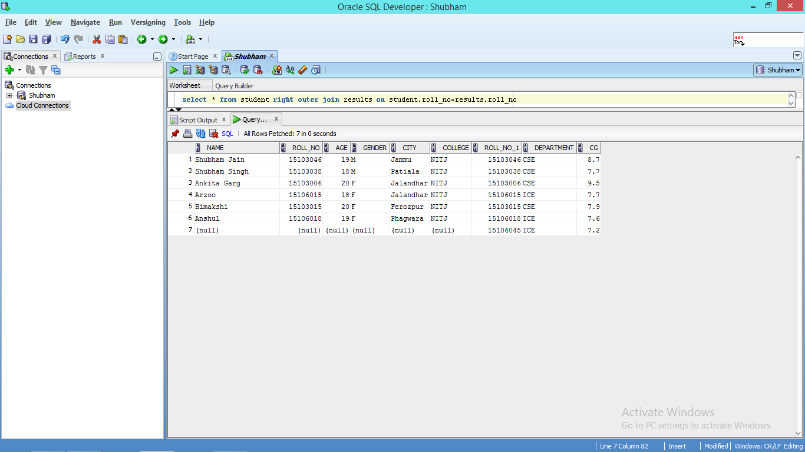

1. FULL OUTER JOIN :

SELECT * FROM student FULL OUTER JOIN results ON student.roll_no=results.roll_no

